
ST. MARY’S UNIVERSITY
Faculty of Informatics
Computer Science Department
Web-Based Purchase Order Management System
A Study Presented As A Partial Fulfilment Of The Requirement For Bsc Degree In Computer Sciense
Done by:
Group members: ID
1. Dawit Teka RCD/0168/2014
2. Temesgen Berhane RCD/0148/2014
3. Wubtsega Sitotaw RCD/0160/2014
4. Yididya Bililign RCD/0150/2014

Advisor: Haileyesus Tilahun Date: Jan 25/ 2025

Web-Based Purchase Order Management System

Authentication of our work

Advisee’s Declaration
We the undersigned declare that this senior project paper is our original work. Prepared under the guidance of Haileyesus Tilahun. All sources of materials used for the manuscript have been duly acknowledged.

Name: Signature:

Date of Submission

Advisor's Declaration
The paper has been submitted for the examination with my approval as the University advisor
Name:
Signature:
Date: -

APPROVED BY THE COMMITTEE
CHAIR PERSON:
SIGNATURE DATE
ADVISOR:
SIGNATURE DATE
EXAMINOR:
SIGNATURE DATE

ACKNOWLEDGMENT

We sincerely appreciate the support and contributions of everyone who played a role in making this project a success. Our deepest appreciation goes to our advisor, Haileyesus Tilahun, for his continuous guidance and support, His valuable insights and constructive feedback have played a great role in shaping our research and improving our approach to the project.
We also extend our thanks to the Administration staff of Upper Awash Agro Industry for providing us with essential information about their organization, It’s operations and it’s workflow . Their input has significantly enriched our understanding of the matter. We are also grateful to all survey participants for dedicating their time to answer our interviews and questioners , as well as for helping us with all needed information with sincerity Their insights have contributed in strengthening our research.
Additionally, we appreciate the support and encouragement from our seniors, our friends and teachers, whose advice and motivation have been invaluable throughout this journey.
Lastly, we thank St. Mary’s University for offering the necessary resources, facilities, and support to help us complete this project. We are grateful to everyone who played a role in this project’s success. Your support and contributions have been instrumental, and we deeply appreciate your efforts.

Table Of Content

CHAPTER - I 1
1. Introduction 1
1.1. Background of the Organization 1
1.2. Statement of the Problem 2
1.3. Objectives of the project 3
1.3.1. General objectives 3
1.3.2. Specific objectives 3
1.4. Methodology 4
1.4.1. Data collection 4
1.4.2. System Development Process Model 4
1.4.3. Design Pattern 6
1.4.4. Programming Language 6
1.5. Tools 7
1.5.1. Hardware Tools 7
1.5.2. Software Tools 7
1.6. Scope and limitation of the project 8
1.6.1. Scope of the project 8
1.6.2. Limitations of the Project 9
1.7. Significance of the Project 9
1.8. Feasibility Study 11
1.8.1. Technical Feasibility 11
1.8.2. Operational Feasibility 11
1.8.3. Economic Feasibility 12
1.8.4. Legal Feasibility 13
1.8.5. Schedule Feasibility 13
1.8.6. Environmental Feasibility 13
1.9. Risk Assessment 14
1.9.1. Risk 14
1.9.2. Risk assumption 15
1.9.3. Constraints 16
1.10. Work Break Down 17
CHAPTER - II 19
2. Business Area Analysis and Requirement Definition 19
2.1. Introduction 19
2.2. Business Area Analysis 19
2.2.1. Detailed Analysis 19
2.2.2. Current system 21
2.2.3. Players of the Existing System 21
2.2.4. Proposed System 22
2.2.5. Forms and Reports Used 25
2.3. Requirement Gathering 26
2.3.1. Requirement Gathering Techniques 26
2.4. Methods of Communication 27
2.4.1. Communication Techniques 27
2.5. Requirement Definition 27
2.5.1. Functional Requirement 27
2.5.2. Collaboration Modeling 36
2.5.3. Non-Functional Requirements 37
2.6. System Modeling 39
2.6.1. Introduction 39
2.6.2. Business Rules Identification 39
2.6.3. System Use Case Diagram 41
2.6.4. Use Case Description 42
2.6.5. Sequence diagramming 52
2.6.6. Activity Diagram 57
2.6.7. Class diagram 59
2.6.8. State chart diagram 61
2.6.9. User interface Prototyping (High fidelity Prototype) 63
CHAPTER - III 66
3. System Design 66
3.1. Introduction 66
3.2. Purpose of the System 66
3.3. Design Goals 67
3.4. Proposed Software Architecture 68
3.4.1. Subsystem Decomposition 69
3.4.2. Component Diagram 72
3.4.3. Deployment Diagram 73
3.4.4. Persistent Data Management 74
3.4.5. Detailed Database Design 75
3.4.5.1. Relational tables 75
3.4.5.2. Normalization 77
3.4.5.3. OO-Relational mapping 80
3.4.6. Access Control and Security 82
3.4.7. Global Software Control 83
3.4.8. Boundary Conditions 85
Conclusion 88
References 89
Appendix 91
I. Interview Questions 91
1. For Suppliers 91
2. For Administrators 92
3. For Employees 93
4. Cross-Functional Questions 93
II. Images 95

List Of Tables

Table 1.1 Programming Language 6
Table 1.2 Hardware Tools 7
Table 1.3 Software Tools 7
Table 1.4 Work Break Down 17
Table 1.5 Work Plan - Gantt Chart 18
Table 2.1 Actor Identification 33
Table 2.2 Non-Functional Requirements 38
Table 2.3 Business Rule Identification 40
Table 2.4 Usecase Description _Register 42
Table 2.5 Usecase Description_Create Account 43
Table 2.6 Usecase Description _Login 43
Table 2.7 Usecase Description _Create PR 44
Table 2.8 Usecase Description_Approve Purchase Request 45
Table 2.9 Usecase Description_Deny Purchase Request 45
Table 2.10 Usecase Description_Post Ads 46
Table 2.11 Usecase Description_Place Bid 46
Table 2.12 Usecase Description_Award Bid 47
Table 2.13 Usecase Description_Track Progress 47
Table 2.14 Usecase Description_Leave a Comment 48
Table 2.15 Usecase Description_Create Purchase Order 48
Table 2.16 Usecase Description_Create Goods Received Note 49
Table 2.17 Usecase Description_Delete Account 50
Table 2.18 Usecase Description_Ban Supplier 50
Table 2.19 Usecase Description_Make Payment 51
Table 3.1 Relational Table_User 75
Table 3.2 Relational Table_Supplier 75
Table 3.3 Relational Table_Report 75
Table 3.4 Relational Table_Account 75
Table 3.5 Relational Table_Purchase Request 76
Table 3.6 Relational Table_Purchase Order 76
Table 3.7 Relational Table_GRN 76
Table 3.8 Relational Table_Address 76
Table 3.9 Relational Table_Bid 77
Table 3.10 Relatinal Table_Role Types 77

List of Diagrams
Diagram 2.1 Essential Usecase_Logistics and Supply Unit 31
Diagram 2.2 Essential Usecase_Budget Control Unit 31
Diagram 2.3 Essential Usecase_General Manager 31
Diagram 2.4 Essential Usecase_Suppliers 32
Diagram 2.5 Essential Usecase_Admin 32
Diagram 2.6 Essential Usecase_Procurement Unit 32
Diagram 2.7 Collaboration Modeling_Purchase Request Approval 36
Diagram 2.8 Collaboration Modeling_Order Fulfillment and Payment 37
Diagram 2.9 Collaboration Modeling_Admin Workflow 37
Diagram 2.10 Sequence Diagram_Purchase Request Approval 52
Diagram 2.11 Sequence Diagram_Supplier Registration and Approval 53
Diagram 2.12 Sequence Diagram_User Management 54
Diagram 2.13 Sequence Diagram_Order Fulfilment and Tracking 55
Diagram 2.14 Sequence Diagram_ Bid Submission and Evaluation 56
Diagram 2.15 AD_Award Bid & Create PO 57
Diagram 2.16 AD_Place Bid 58
Diagram 2.17 AD_Award bid & PO 58
Diagram 2.18 Class Diagram 60
Diagram 2.19 SCD_Supplier Registration 61
Diagram 2.20 SCD_PR Lifecycle 61
Diagram 2.21 SCD_Bid Lifecycle 62
Diagram 2.22 SCD_GRN Lifecycle 62
Diagram 3.1 Sub-System Decomposition Diagram 71
Diagram 3.2 Component Diagram 72
Diagram 3.3 Deployment Diagram 73
Diagram 3.4 ER Diagram of the System 79

List of Images
Image 1.1 Incremental Model 5
Image 2.2 Essential UI_Login 35
Image 2.3 Essential UI_Supplier Signup 35
Image 2.4 Essential UI_Procurement Dashboard 35
Image 2.5 System Use Case Diagram 41
Image 2.6 High Fidelity UI_Login 63
Image 2.7 High Fidelity UI_SignUp 63
Image 2.8 High Fidelity UI_GM Review Request 64
Image 2.9 High Fidelity UI_GM Comment and Deny Request 64
Image 2.10 High Fidelity UI_Procurement Unit View Payment History 65
Image 2.11 High Fidelity UI_Procurement Unit Evaluate Bids 65
Image 0.1 Purchase Requisition Fom 95
Image 0.2 Proforma Evaluation Form 96
Image 0.3 Purchase Order Form 97
Image 0.4 GRN Form 98
Image 0.5 Goods in Transit Form 99

This page intentionaly let Blank

CHAPTER - I

Introduction
The evolution of digital solutions has transformed traditional procurement processes, enabling organizations to automate workflows, reduce human error, and ensure real-time data transparency. Upper Awash Agro Industry, a leading agricultural enterprise in Ethiopia, currently relies on manual, paper-based procurement workflows that lead to delays, inefficiencies, and operational bottlenecks. This project proposes a Web-Based Purchase Order Management System built on modern technologies (Laravel MVC framework, SQL database) to digitize and streamline procurement operations across the company’s 7,000+ employees and multiple operational sites.
By replacing manual processes with an automated platform, the system aims to reduce approval times by 50%, eliminate paper usage, and improve supplier collaboration, directly addressing challenges outlined in the problem statement.

Background of the Organization
Upper Awash Agro Industry Enterprise is a prominent agricultural company based in Ethiopia. The establishment of the company can be traced back and attributed to 4 farms during the rule of Emperor Haile Selassie, Melka Awara Farm Development (est 1904), Nura Hera Farm Development (est 1956), Tibla Farm (est 1957), and Merti (est 1963). After the fall of the Emperial rule, Derg regime took control over all four farms in 1972 and started operating them as one entity under the name of Nura Hera Farm Development. Since then the company have changed it’s name, product, and ownership throughout the years. Currently It’s owned and operated by MIDROC Investment Group.
Currently Upper Awash Agro Industry operates farms in two zones: East Shewa, specifically in the Bosset district, and in the Arsi zone, covering the Merti and Jeju districts with a branch and administration office in Addis Ababa. The company is primarily involved in the production and processing of a diverse range of agricultural products, including:
- Fresh and processed fruits and vegetables
- Cereals
- Cut flowers
- Seeds
- Fiber crops
The company currently employs over 7,000 individuals, including full-time, contractual, and seasonal workers. Monthly payroll expenses exceed 14 million Birr. In the 2014 Ethiopian Calendar year, the company paid over 150 million Birr in revenue tax. Additionally, the company demonstrates its commitment to social responsibility by donating over 10 million Birr annually.

Statement of the Problem
Upper Awash Agro Industry operates across multiple locations, including rural farms, processing plants, and urban offices. The company relies on a steady supply of goods to support its operations. Currently, all purchase requests must go through the head office in Addis Ababa for approval. While this centralized system ensures oversight, it creates delays and inefficiencies, disrupting operations and increasing costs.
The procurement process is slowed by manual workflows and poor communication systems. Remote sites struggle to generate purchase requests, relying on outdated methods such as manual forms or poorly integrated communication channels. This process is prone to errors and delays, especially when incomplete or unclear requests require repeated clarifications.
Centralized approval creates a major bottleneck as all requests must be reviewed by the general manager in Addis Ababa, regardless of urgency or complexity. This overload causes delays even for routine purchases, while urgent needs, such as perishable goods or spare parts, often face critical delays. Additionally, the lack of a systematic method to prioritize requests leads to disruptions, as essential items may not be addressed promptly.
The collection of proforma invoices introduces further delays and inefficiencies. Staff often need to physically visit suppliers or rely on fragmented communication channels to obtain quotes, a process that is both time-consuming and labor-intensive. Suppliers may also delay responses, especially when requests are unclear. If initial invoices are rejected or additional quotes are needed, the process must be repeated, wasting time and resources.
These inefficiencies disrupt operations, as delays in procuring essential goods can halt farm activities, interrupt processing schedules, and impact office functions. Emergency purchases to address these delays often come at higher costs, further straining budgets. The reliance on manual processes also increases administrative workload, adding to overall expenses.
The prolonged procurement process strains supplier relationships. Delays in finalizing deals, especially when proforma invoices are only valid for a short period, frustrate suppliers and weaken partnerships, reducing the company’s ability to negotiate favorable terms. Employees at remote sites also feel powerless and frustrated due to the lack of autonomy and delays in addressing their needs.
The current system limits the company’s ability to adopt modern technology that could streamline procurement activities. Manual processes make scaling operations difficult as the company grows. The lack of transparency and centralized tracking also creates risks of unethical practices, as approvals and transactions are harder to monitor effectively.

Objectives of the project

General objectives
To develop a digital purchase requesting and ordering system that streamlines procurement processes, reduces delays, enhances transparency, and improves the overall efficiency of purchasing operations at Upper Awash Agro Industry by replacing the traditional manual paper-based system.

Specific objectives
- To improve the efficiency of purchase requests and approvals.
- To integrate supplier engagement for streamlined operations.
- To implement digital audit trails to log all procurement activities, including request submissions, approvals, and transactions, ensuring accountability.
- To reduce delays and operational disruptions.
- To facilitate user-friendly access across locations.
- To promote environmental sustainability by reducing paper usage.

Methodology

Data collection
The data collection methodology will involve gathering information about the current procurement processes, identifying inefficiencies, and understanding user requirements for the proposed system. We plan to use several methods to collect the required data, to brainstorm solutions, and to help us develop approaches that stakeholders approve of and wish to see incorporated into the proposed system. These methods include :
- Interviews: We held interviews with key stakeholders, including procurement staff, department heads, and few suppliers, to gather qualitative insights into main points and expectations.
- Observation: We plan to observe the current procurement workflows to document how requests are processed, approved, and executed. This will allow us to identify delays or inefficiencies. While certain processes and documents might not be available for direct observation due to authorization constraints, we will work closely with stakeholders to obtain a clear understanding of those operations.
- Document Analysis: We plan to analyze past purchase records, approval forms, and correspondence to understand data volumes, processing times, and error frequencies in the current system. This analysis will provide a quantitative foundation for identifying critical improvement areas.
- Workshops: We hope to organize workshops with stakeholders to brainstorm solutions, discuss possible system features, and validate the requirements. These workshops will serve as a platform to align all participants on the system's objectives and functionalities.

System Development Process Model
System development process models are structured approaches that provide frameworks for planning, creating, testing, and deploying software systems. For this project, we chose the Incremental Development Model.
The Incremental Development Model emphasizes breaking the system into smaller, manageable components that are developed, tested, and delivered in incremental stages. This approach allows us to build the system step by step while continuously refining and improving each module as new increments are added.
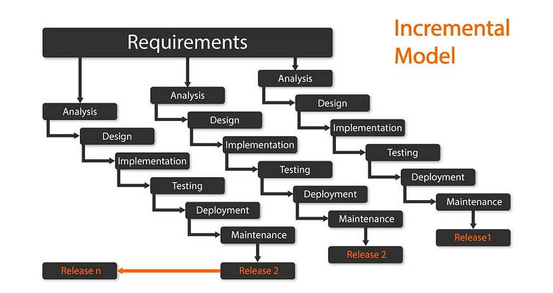
Image 1.1 Incremental Model
The Incremental Development Model was chosen for our Purchase Order Manaagement system due to its ability to address changing requirements while maintaining steady progress. Since the system’s requirements may evolve based on our advisor’s input and user feedback, this model provides the flexibility to incorporate changes without disrupting the overall development process. Each increment delivers a functional module of the system, allowing stakeholders to review and validate the progress at regular intervals.
This model is particularly suitable for our project as it helps reduce risks by enabling early detection of issues within individual increments. By focusing on smaller, manageable parts of the system, we can ensure that each module is thoroughly tested and optimized before integration. The step-by-step approach also supports ongoing learning and adaptation, which is especially valuable in an academic setting where team members are still gaining experience in software development.
With a team of four developers, the Incremental Development Model promotes effective collaboration by dividing the workload into clear, actionable goals. Each team member can focus on a specific increment, ensuring parallel development and faster progress. Additionally, delivering functional components incrementally allows us to present visible progress to our advisor facilitating timely feedback and alignment with project objectives.
Overall, the Incremental Development Model provides a structured yet flexible framework that aligns with the dynamic nature of our project, accommodates changing requirements, and ensures consistent progress toward a fully functional system.

Design Pattern
The Model-View-Controller (MVC) design pattern was chosen for the project. This pattern separates the application into three interconnected components: the Model (data management), the View (user interface), and the Controller (business logic and user input handling).
The MVC pattern ensures a clear separation of concerns, making the system easier to develop, test, and maintain. It supports scalability and allows for independent development of components, which is crucial for a system as complex as procurement management. For instance, the Model can be developed to handle database interactions while the View focuses on delivering a user-friendly interface.

Programming Language
Components | Programming Language/Frameworks | Reason For Selection
Front-end Development | HTML, CSS, JavaScript | Ensures a responsive and interactive user interface.
Framework | Laravel | Provides robust features for dynamic and scalable designs.
Back-end Development | PHP | Widely used, well-documented, and compatible with Laravel.
Database Management | SQL | Efficient for structured data storage and supports complex queries.
Table 1.1 Programming Language

Tools

Hardware Tools
Devices | Description
Personal Computers | Used for coding, testing, and designing the web app; includes desktops or laptops.
Mobile Devices | Used for testing the app's responsiveness and performance on smaller screens.
Storage Devices | External hard drives or cloud storage for backups and storing large datasets.
Dongle | For internet access
Table 1.2 Hardware Tools

Software Tools
Softwares/Tools | Description
Visual Studio Code | Programming language for backend and frontend development.
Microsoft SQL | Relational database management systems for storing procurement data.
Chrome, Edge | For testing and debugging the app's performance on different browsers.
Visio, Draw.io, PlantUml | Tools for creating diagrams like class diagrams, ER diagrams, and workflows. And also for UI prototyping
Github | For version control and colaborative development
Figma, Canva | UI prototyping tools
WhatsApp, Telegram | Communication, file sharing, video conference tool
Table 1.3 Software Tools

Scope and limitation of the project

Scope of the project
The scope outlines the boundaries of the project, including what will and will not be covered.
- Where it works: The system works across various organizational locations, including farms, processing plants, and corporate offices.
- For whom: It is designed for Supply and Logistics unit members, procurement teams, departmental heads, and suppliers involved in the procurement process.
- When: It facilitates procurement activities during regular business operation hours and ensures real-time updates.
- On what platform: The system is web-based with a mobile-friendly interface for accessibility from both urban and remote locations.
- Included expected MAIN features:
  - Core Functionalities:
    - Digital submission of purchase requests.
    - Workflow automation for approvals and prioritization.
    - Integration with suppliers for proforma invoice submissions and comparisons.
    - Real-time tracking of requests and orders.
    - Reporting and analytics for procurement activities.
  - Accessibility:
    - Role-based access control for secure data handling.
  - Data Management:
    - Centralized database for procurement records.
    - Archiving and audit trails for compliance.
  - User Support:
    - Training sessions for employees and suppliers.
    - Help-desk support for troubleshooting issues during and after implementation.

Limitations of the Project
- Features that are not covered by our project
- Advanced AI-driven procurement decision-making tools.
- Hardware procurement such as computers or networking equipment.
- Other unrelated business operations like Inventory Management, Marketing, or HR processes.
- Where does it not work?
- Locations with unreliable or no internet connectivity.
- When doesn't it work?
- During internet outages or periods of insufficient connectivity.
- Who cannot use it?
- Suppliers or employees who are not technologically adept or unwilling to adapt to the system.
- On what platforms can a user not use it?
- Platforms other than web or mobile, such as standalone desktop-only environments or legacy systems.

Significance of the Project
The implementation of a digital purchase requesting and ordering system for Upper Awash Agro Industry offers critical benefits across operational, financial, strategic, and environmental dimensions. It addresses inefficiencies in the current manual system and empowers the organization to enhance productivity, transparency, and decision-making.

- Operational Significance:
- Increased Efficiency: Automation reduces delays caused by manual approvals and proforma collection, enabling faster responses to operational needs.
- Improved Accuracy: Minimizes human error in data entry and approvals, resulting in accurate records and decisions.
- Seamless Communication: Centralizes communication between operational sites, the Addis Ababa office, and suppliers, ensuring streamlined coordination and preventing miscommunication.
- Financial Significance:
- Cost Savings: Decreases administrative overhead, paper costs, and enhances supplier price negotiations.
- Enhanced Budget Management: Enables real-time tracking of procurement expenses, helping the company avoid overspending and adhere to budgets.
- Strategic Significance:
- Scalability: The system can be easily scaled to accommodate company growth and additional operational sites.
- Data-Driven Decisions: Provides procurement analytics and reports for informed management decisions, improving strategic planning.
- Competitive Advantage: Strengthens supplier relationships and ensures timely operations, giving the company an edge in the industry.
- Environmental Significance:
- Reduction in Paper Usage: Supports sustainability goals by lowering paper consumption and the organization’s carbon footprint.
- Eco-Friendly Operations: Streamlined processes reduce unnecessary travel for delivering request orders to the main office, further minimizing carbon emissions.
- Uses and Benefits for Users:
- Procurement Officers:
  - Simplifies and speeds up purchase request submissions.
  - Reduces errors in data entry and processing.
- Management Team:
  - Provides real-time insights into procurement activities for better oversight.
  - Enhances decision-making with detailed analytics and reporting.
- Suppliers:
  - Improves communication and coordination with the company.
  - Ensures timely order processing and payment.
- Environmental Stakeholders:
  - Aligns with sustainability objectives by minimizing paper usage and emissions.
  - Demonstrates the company’s commitment to eco-friendly practices.

Feasibility Study
A feasibility study evaluates the practicality of the proposed system from various aspects to ensure its successful development and implementation. The aspects analyzed in this study include technical, operational, economic, legal, and schedule feasibilities.

Technical Feasibility
This aspect assesses whether the technical requirements for the proposed system are achievable using available technologies.
- Infrastructure Requirements: Upper Awash Agro Industry will need to invest in a reliable IT infrastructure, including a web server, database management system, and internet connectivity across all operational locations.
- Technical Expertise: The system development will require skilled personnel proficient in web development, database management, and system integration. As the company transitions from a manual system, user training for employees and suppliers will also be necessary. These resources are readily available in the IT market.
- System Scalability: The proposed system will be designed to handle increasing volumes of purchase requests and supplier data, ensuring scalability.
Conclusion: The project is technically feasible given the current availability of technologies and expertise.

Operational Feasibility
This aspect evaluates whether the organization and stakeholders can successfully adopt and use the proposed system.
- Stakeholder Readiness: Employees at rural farms, processing plants, and offices will benefit from faster, transparent processes. Suppliers will also benefit from simplified interactions with the company. However, resistance to change from staff accustomed to the manual system may arise.
- Training and Support: A comprehensive training program for employees and suppliers, along with clear documentation, will ensure smooth adoption. The system interface will be user-friendly, minimizing the learning curve.
- Impact on Operations: The new system will significantly reduce delays, improve resource allocation, and enhance supplier relationships, leading to better operational outcomes. Early challenges, such as adapting to a digital workflow, will diminish over time.
Conclusion: The project is operationally feasible with proper change management and training.

Economic Feasibility
This aspect evaluates whether the system is financially viable, considering both initial investments and long-term benefits.

- Initial Costs:
- System development or procurement: Estimated cost of software design and database setup.
- Hardware upgrades: Possible upgrades for older systems in remote locations.
- Training costs: Costs for training employees and suppliers.
- Operational Costs
- Ongoing maintenance and support of the system.
- Benefits and ROI (Return on Investment)
- Reduction in paper usage and administrative costs associated with manual processes.
- Improved efficiency leading to cost savings in procurement and reduced emergency purchases.
- Better supplier management and competitive pricing due to streamlined proforma collection.
- Payback Period: The cost savings and efficiency improvements are expected to offset initial investments within 2-3 years.
Conclusion: The project is economically feasible with high potential for long-term cost savings.

Legal Feasibility
Here we examine whether the proposed system complies with applicable laws and regulations.
- Data Protection and Privacy Laws: The system must comply with local and international data protection regulations, such as Ethiopia’s ICT policies and any applicable global standards. Measures such as encryption and secure user authentication will ensure compliance.
- Contractual Obligations: Supplier agreements may need updates to align with the digital system, particularly for requirements like proforma submission via the platform.
- Licensing and Copyright: If using third-party software components for payment, proper licensing agreements must be obtained.
Conclusion: The project is legally feasible with adherence to relevant laws and updated supplier agreements.

Schedule Feasibility
This aspect evaluates whether the system can be developed and deployed within a reasonable timeline.
- Estimated Timeline
- Planning and Requirements Analysis: 2-3 months.
- System Design and Development: 5-8 months.
- Testing and Deployment: 2-3 months.
- Training and Rollout: 1-2 months.
- Potential Delays: Delays may occur due to unexpected technical challenges or resistance during training. A detailed project plan with milestones and contingency buffers will help mitigate such risks.
Conclusion: The project is schedule-feasible, with a total timeline of 10-16 months for full deployment.

Environmental Feasibility
This aspect assesses the project's potential impact on the environment.
- Reduction in Paper Usage: The system will drastically reduce the dependency on paper, aligning with sustainable practices and reducing waste.
In conclusion, the project is environmentally feasible and aligns with sustainability goals.
Overall the feasibility study confirms that the proposed digital purchase requesting and ordering system for Upper Awash Agro Industry is technically, operationally, economically, legally, schedule-wise, and environmentally feasible. Proper planning, stakeholder engagement, and investment in infrastructure will ensure its success, leading to significant operational improvements and long-term cost savings.

Risk Assessment

Risk
- Operational Risks
- Resistance to Change: Employees and suppliers might resist transitioning from manual processes to a digital procurement system. This resistance can stem from a lack of familiarity with the new technology, fear of job redundancy, or skepticism about the system's effectiveness.
  - Mitigation: Conduct regular training sessions to familiarize users with the system and demonstrate its benefits. Engage stakeholders early in the development process to build trust and address concerns. Offer continuous support post-implementation to ease the transition.
- Incomplete Adoption: Certain departments or sites may fail to fully utilize the system, leading to inconsistent implementation and reduced effectiveness.
  - Mitigation: Develop a clear adoption strategy that includes mandatory onboarding for all departments. Use incentives or performance metrics to encourage usage. Monitor system usage regularly to identify and address gaps in adoption.
- Technical Risks
- System Downtime: Unplanned technical issues, such as server failures, software bugs, or maintenance challenges, could disrupt operations and hinder productivity.
  - Mitigation: Implement a robust server infrastructure with failover systems and regular maintenance schedules. Maintain backup servers to ensure business continuity.
- Data Breaches: Sensitive procurement data may be vulnerable to unauthorized access, which could result in financial losses and reputational damage.
  - Mitigation: Employ strong encryption protocols, firewalls, and multi-factor authentication for system access. Regularly update and patch the system to address security vulnerabilities. Conduct periodic security audits and train staff on cybersecurity best practices.
- Project Risks
- Budget Overruns: Unexpected costs during development, testing, or deployment phases could exceed the allocated budget, jeopardizing the project's completion.
  - Mitigation: Perform thorough budgeting and allocate a contingency fund to handle unforeseen expenses. Regularly review expenditures and ensure that all spending aligns with the project scope. Engage in cost-effective practices, such as open-source tools or cloud-based services.
- Schedule Delays: Development, testing, or training phases may take longer than anticipated, delaying the system's implementation.
  - Mitigation: Create a detailed project timeline with realistic milestones. Assign responsibilities clearly and conduct regular progress reviews. Address bottlenecks early and allocate additional resources if necessary to meet critical deadlines.

Risk assumption
- Employee Cooperation: It is assumed that employees and management will cooperate during the transition and provide feedback for improvements.
- Supplier Participation: Suppliers are expected to adopt the system and provide the necessary proforma invoices through the platform.
- Technical Support Availability: Skilled personnel will be available to address technical challenges promptly.
- Stable Internet Connectivity: It is assumed that internet infrastructure in all locations will support system usage.

Constraints
Technical Constraints
- Infrastructure: Limited IT infrastructure at rural sites may require additional investment in connectivity and hardware.
Resource Constraints
- Budget Limitations: The project must stay within the allocated financial resources, which might limit feature implementation.
- Time Restrictions: The project must be completed within a timeline of 10-16 months to avoid disruptions to current operations. Also, considering the fact that we will be concurrently undertaking the project alongside learning activities, our time for project completion may be limited.
Regulatory Constraints
- Compliance Requirements: The system must comply with local data protection laws and any international standards applicable to supplier dealings.
User Constraints
- Skill Levels: The digital literacy of employees and suppliers may vary, necessitating a simple and intuitive system interface.

Work Break Down
The project work plan below outlines the timeline in days, milestones required to be achieved with each activity, and outcomes as deliverables for each phase of the project.
Phase | Activities | Duration | Deliverables
Requirement | Project analysis and identification | 5 | - Scope  - Requirement specification  - Feasibility study
 | Feasibility study | 20
 | Total | 25
Planning | Estimations | 10 | - Resource allocation  - Project schedule  - Risk assessment document
 | Scheduling | 5
 | Risk analysis | 10
 | Total | 25
System Design | Use case modeling | 15 | - System architecture diagrams  - Data model diagrams  - Use case diagrams  - User interface wireframes
 | UI Prototype | 20
 | Sequesnce Diagram | 7
 | Class Diagram | 3
 | ER Diagram | 4
 | Activity Diagram | 6
 | Total | 55
Development | Front-end development | 40 | - Database and database queries  - Functional system components
 | Back-end development | 40
 | Database Integration | 10
 | API Integration | 15
 | Total | 105
Testing | Unit testing | 8 | - Test plan document  - Test cases  - Test environment setup  - Discover defects, bugs and other issues
 | Integration testing | 4
 | Functional testing | 2
 | Security testing | 6
 | Total | 20
Deployment | Total | 5 | - A fully functional web app
Training | Training key personnel | 5 | - Training manuals  - Trained users
 | Training IT staff | 10
 | Total | 15
Table 1.4 Work Break Down
Work Plan Timeline (Gantt Chart Format)
Phase | Months
 | 1 | 2 | 3 | 4 | 5 | 6 | 7 | 8 | 9 | 10 | 11 | 12 | 13
Requirement
Planning
System Design
Development
Testing
Deployment
Training
Table 1.5 Work Plan - Gantt Chart

CHAPTER - II

Business Area Analysis and Requirement Definition

Introduction
The Business Area Analysis and Requirement Definition phase is a critical component in the development of the Web-Based Purchase Order Management System for Upper Awash Agro Industry. This chapter provides a comprehensive understanding of the business environment, detailing the current system and the challenges it poses, analyzing stakeholders, and outlining the proposed system's features and functionalities. Furthermore, the methodologies employed to gather requirements are discussed to ensure that the system aligns with the organization’s operational needs and objectives.

Business Area Analysis

Detailed Analysis
We conducted an in-depth study of the procurement process at Upper Awash Agro Industry to analyze its current state, challenges, and potential areas for improvement. The aim was to identify inefficiencies and develop solutions to streamline operations, reduce costs, and minimize delays. To achieve this, we employed various data collection techniques, including interviews, observations, and surveys with key stakeholders such as procurement staff, farm managers, and administrative personnel.
We used various meant to gather data from employees and other stakeholders to gethat our data. These participants included procurement officers, farm supervisors that were currently available around their head office in Addis Ababa, and administrative staff.
From what we manage to gather, all of the participants highlighted delays caused by the reliance on manual communication methods, such as phone calls and paper-based requests. Furthermore, most of respondents mentioned that the centralized approval system often results in bottlenecks, with urgent purchases delayed due to lengthy approval times. Repetitive tasks, such as manually generating purchase orders and tracking order statuses, were identified by the procurement unit employees we questioned.
We asked participants about the types of solutions they believed would most improve the procurement process. A majority of them expressed a strong preference for an automated approval workflow to reduce delays, and integration of digital tools for real-time order tracking since the only option they have right now is calling the main office and asking for updates. Additionally, an overwhelming number of participants supported the implementation of a supplier management system to improve communication and relationships with vendors.
When asked about challenges specific to rural farms, they identified difficulties in synchronizing procurement requests between farms and the central office. Since the curent state of our country is not ideal for safe travels in rural areas, they can not send purchase requests as they please, they had to wait for optimal coditions even as requests are pilling up.
We also conducted a series of interviews with department heads to understand their expectations for an improved procurement system. Several key insights emerged, including the need for role-based access controls, customizable reporting features, and mobile accessibility to accommodate field staff who may not always have access to computers.
Additionally, we attempted to engage with the Ministry of Industry and Trade to understand relevant regulatory frameworks affecting the procurement process. Unfortunately, we were unable to secure a meeting. Instead, we contacted the Ethiopian Chamber of Commerce and Sectoral Associations, whose representatives provided valuable insights into the broader challenges faced by businesses in Ethiopia, including currency fluctuations and vendor reliability issues.
Based on our findings, it is evident that automation and digitalization of the procurement process at Upper Awash Agro Industry are critical to improving efficiency and reducing costs. By addressing bottlenecks such as manual communication, centralized approvals, and repetitive tasks, the proposed system has the potential to significantly enhance productivity and ensure the seamless operation of the company’s diverse facilities.

Current system
At Upper Awash Agro Industry, the procurement process currently follows a manual and paper-based approach. It begins when employees from the Supply and Logistics Unit, stationed at various farms and processing plants, submit purchase requests using physical forms to the Addis Ababa office. These forms then go through a lengthy approval process, where the general manager manually reviews and approves each request. This traditional method creates significant bottlenecks, especially for high-volume or low-priority items.
Once the requests are approved, the next step involves physically visiting suppliers to collect multiple proforma invoices, a task that further delays the process. Back at the office, the gathered proforma invoices are manually opened, and their prices are entered into an Excel spreadsheet. The supplier with the lowest bid is then selected and awarded the contract.
Following this, the purchase orders are manually prepared and sent to the chosen supplier. Throughout this entire process, there is no real-time tracking system in place, making it difficult to monitor progress or generate accurate reports. The lack of automation and streamlined procedures hinders efficiency and increases the risk of errors at every stage.

Players of the Existing System
Players of the exsting system refers to the individuals or organizations that are involved in or affected by the current system. Key stakeholders in the current procurement system include:
- Procurement Staff: Responsible for receiving approved Purchase Requests, generating Purchase Orders, obtaining proforma invoices, selecting winning bids, awarding the winning bidder, and finalizing orders by paying the suppliers upon receiving the item or goods.
- Budget Control Unit: They are responsible for evaluating the cost of the items in the purchase requests and check if they fall within the budget restriction of the requesting department.
- General Manager: Approves all purchase requests, creating a centralized point of decision-making.
- Supply and Logistics Unit Employees: These employees generate the Purchase Requests for items to be purchased when they’re either low or anavailable in inventoy. Currently they have no means to check the status of their requests other than calling the main office procurement department.
- Suppliers: Provide proforma invoices and goods but face delays and inefficiencies in communication.

Proposed System
The proposed system focuses on revolutionizing the procurement process at Upper Awash Agro Industry by leveraging technology to address inefficiencies and enhance operational efficiency. By introducing a digitized platform, the system aims to streamline workflows, enable real-time tracking, and foster better supplier integration, thereby reducing costs, delays, and redundancies in procurement operations.
The primary objective of the system is to create a hybrid platform that combines software functionalities with process automation to address the bottlenecks identified in the current procurement workflow. These bottlenecks include manual communication, centralized approvals, and repetitive administrative tasks, all of which impede efficiency and productivity. The proposed solution will serve as a bridge between the company’s rural farms, processing plants, and administrative offices in Addis Ababa, ensuring seamless and consistent procurement operations.
Key Features of the current system include:
- Digitized Purchase Request Submission Platform
The system introduces a web-based platform where users from different departments can submit purchase requests digitally. This eliminates the need for manual forms or phone-based requests, reducing paperwork and potential errors. Users can input item details, required quantities, and deadlines, with requests automatically routed to the appropriate approvers based on predefined workflows.
- Supplier Integration
The system integrates a supplier database, allowing procurement officers to interact directly with pre-approved vendors. Suppliers can update product availability, pricing, and delivery schedules in real-time, ensuring accurate and up-to-date information for decision-making. Additionally, the platform allows for onboarding new suppliers, creating a competitive marketplace.
- Streamlined Workflow
By automating approval processes, the system minimizes delays caused by centralized decision-making. Role-based access controls ensure that only authorized personnel can review and approve requests. Automated notifications keep all stakeholders informed of the status of requests, reducing unnecessary follow-ups and miscommunication.
- Real-Time Tracking
Real-time tracking of purchase requests, approvals, order fulfillment, and delivery schedules is a core feature of the proposed system. Users can monitor the status of their requests through a centralized dashboard, while automated alerts notify them of critical updates, such as delays or order completions.
- Report Generation
The system includes advanced reporting capabilities, allowing management to generate detailed reports on procurement activities, expenditures, vendor performance, and inventory status. These reports can be customized and exported in various formats, providing valuable insights for decision-making and strategic planning.
- Online Payment Integration
To facilitate seamless transactions, the platform supports online payment options, enabling direct payments to suppliers through secure gateways. This feature reduces the reliance on manual payment methods, improving financial transparency and efficiency.
The implementation of the proposed system will significantly enhance operational efficiency across the procurement process at Upper Awash Agro Industry. By automating repetitive tasks and digitizing workflows, the system eliminates the delays and errors commonly associated with manual processes. Employees will no longer need to rely on physical forms or time-consuming manual communication, freeing up valuable time and resources to focus on strategic tasks.
The system also offers substantial cost-saving opportunities. Real-time tracking and integration with suppliers ensure better inventory management, reducing unnecessary expenditures from overstocking or last-minute emergency purchases. With transparent pricing from suppliers and streamlined approvals, procurement decisions can be made more effectively, leading to optimized spending across the company’s operations.
Transparency and accountability are integral to the proposed system’s design. A centralized digital platform records every action, from purchase request submissions to approvals, order tracking, and payments. This comprehensive audit trail improves oversight and ensures compliance with company policies. Decision-makers gain access to accurate, up-to-date data, which allows them to make informed choices and address bottlenecks proactively.
The system also strengthens collaboration by fostering closer partnerships with suppliers. Integrated supplier portals allow vendors to update product availability, pricing, and delivery timelines in real time, ensuring that procurement officers always have accurate information. This enhanced communication not only reduces misunderstandings but also improves vendor relationships, creating a more reliable supply chain for the company.
Finally, the system’s scalability ensures that it will remain valuable as Upper Awash Agro Industry grows. New users, features, and integrations can be seamlessly added to the platform, making it a long-term solution for the company’s evolving needs. Whether expanding operations or adapting to new business challenges, the proposed system provides a robust foundation for ongoing innovation and efficiency in procurement operations.
- Process Workflow of the Proposed System:
  - Setup and Configuration: Users register or get registered onto the platform and configure their profiles. Department-specific workflows and approval hierarchies are established during this stage.
  - Purchase Request Submission: Users submit purchase requests through a standardized digital form. Requests are automatically routed to the appropriate approvers based on predefined rules.
  - Approval and Vendor Matching: Approvers review requests and either approve, reject, or request modifications. Once approved, the system matches the request with suitable vendors based on the item type, delivery timeline, and cost.
  - Order Placement and Tracking: The system generates purchase orders and sends them to the selected vendor. Users can track the order’s progress, from vendor confirmation to delivery, through the platform.
  - Payment and Reporting: Once the order is delivered and verified, payment is processed through the online payment gateway. Detailed reports on the procurement activity are generated for management review.
In conclusion, the proposed system is a comprehensive solution designed to address the unique challenges of procurement in a complex business environment like that of Upper Awash Agro Industry. By integrating advanced digital tools and automation, the system enhances efficiency, transparency, and collaboration across all stages of the procurement process. Its features, including real-time tracking, supplier integration, and report generation, position the company to better meet the demands of its operations while supporting future scalability and innovation.

Forms and Reports Used
Some of the forms and reports utilized in the current systems are discussed down below:
Purchase Request Form
The Purchase Request Form is a essential component of the procurement process. It captures critical details required for initiating a procurement activity, including the item description, quantity, unit of measurement, and the requester's details. This form is typically filled out by the Logistics and Supply Unit at various locations, including farms, processing plants, and corporate offices.
The primary function of this form is to provide a standardized and comprehensive way to collect procurement data, ensuring consistency and accuracy. The form's structure helps avoid miscommunication by clearly outlining the necessary fields, such as justification for the request and a timeline for delivery. These details are essential for prioritizing requests and understanding the operational need behind each procurement activity.
Proforma Invoice
The Proforma Invoice is used by suppliers to submit their offers in response to the requests they receive from procurement unit employees. It includes fields for the supplier’s contact details, bid amount, delivery timeline, and any additional terms or conditions. The for not being standardised posses a challenge for the procurement team, making it quiet difficult for the team to evaluate them.
Evaluation, Selection, and Approval Form
This form is generated and utilized by the Procurement Unit Employees. After selecting all the proforma invoces they can within the given timeframe, they manually input the prices and the names of the suppliers into a spreadsheet document for every item on the PO and evaluate the prices submitted by the suppliers. Then the procurement officers award the bid to the suppliers with the lowest price in each of the listed items.
Purchase Order Form
The Purchase Order Form is generated once a bid is accepted. This form includes the details of the selected supplier, agreed pricing, delivery timeline, and payment terms. Its function is to formalize the agreement between the company and the supplier, serving as a contractual document for fulfilling the order, and also to notify the winner on the items they won the bidding process on.
Goods Received Note (GRN) Form
The GRN Form is used to verify the receipt of goods. It captures details such as the purchase order reference, items received, quantities, and any discrepancies observed. Verified by the Procurement Unit, this form ensures that the delivered goods meet the agreed-upon terms.

Requirement Gathering

Requirement Gathering Techniques
To ensure the development of a system that aligns with Upper Awash Agro Industry’s needs, various requirement-gathering techniques were employed. These include:
- Interviews: Conducted with procurement staff, department heads, and suppliers to gain insights into pain points, expectations, and desired features.
- Observation: The project team observed the existing procurement process to identify inefficiencies and understand workflows.
- Document Analysis: Reviewed existing forms, purchase records, and communication logs to evaluate data volumes, error rates, and processing times.
- Workshops: Facilitated collaborative sessions with stakeholders to brainstorm solutions, validate requirements, and prioritize features.
By employing these techniques, we can ensured that the proposed system would address the organization’s current challenges while being user-friendly and adaptable to future needs.

Methods of Communication

Communication Techniques
Effective communication is essential for the success of this project. The communication techniques employed include:
- Email and Messaging Platforms: For sharing updates, documentation, and quick responses among stakeholders.
- Regular Meetings: Holding verious meetings sessions with stakeholders, when they’re available, to review progress, address challenges, and ensure scope and functionality alignment.
- Workshops: Organized to help us understand innerworkings of what a procurement process is and what that process intails, and make sure we are inline with the scope and dimention of those processes by communicating and brainstorming with the stakeholders and receive feedback.

Requirement Definition
Requirement definiton is the process of identifying and documenting the specific needs, goals, and constraints of a project. This includes identifying the stakeholders and their requirement, as well as defining the functional and non-functional requirements of the project.
The purpose of requirement definition is to ensure that the project meets the needs of the stakeholders and delivers the desired outcome. It helpsto clarify the scope of the project and serve as a basis for the project.

Functional Requirement
A Functional Requirement is a desription of a service the web app must offer. It describes the application system and it’s components. All functionalities that are listed and described in this section needs to be included in the system development because the system provides these functionalities as a service when the implementation is over.
- The system allows suppliers to register by providing necessary identification and business information.
- The system enables all users (Logistics and Supply Unit, Budget Control Unit, General Manager, Procurement Unit, Suppliers, Admin) to log in to their respective accounts using valid credentials, ensuring controlled access and authentication.
- The system allows the admin to create, edit, delete, and manage user accounts for all roles.
- The system allows suppliers to update their profile details, such as business name, contact information, and other relevant details.
- The system enables the Logistics and Supply Unit to create purchase requests by submitting item descriptions, quantities, urgency, and other required details.
- The system allows the General Manager to approve or deny purchase requests, ensuring compliance with organizational policies.
- The system enables the General Manager and the Budget Control Unit to leave comments on purchase requests for clarification or additional details.
- The system allows the Procurement Unit to post approved purchase requests as advertisements on the website for suppliers to view and bid on.
- The system enables suppliers to view available purchase request ads and place bids with detailed information, including prices and delivery timelines.
- The system allows the Procurement Unit to review submitted bids and award the bid to the most suitable supplier.
- The system allows the Procurement Unit to generate purchase orders after awarding a bid, ensuring that the order details are clearly communicated to the winning supplier.
- The system enables the Procurement Unit to generate a Goods Received Note (GRN) after verifying the receipt of goods or services from the supplier.
- The system allows the Procurement Unit to process and record payments for completed purchase orders.
- The system allows the General Manager and the Logistics and Supply Unit to track the progress of purchase requests, from creation to fulfillment.
- The system allows the admin to approve or reject supplier registrations to ensure that only legitimate suppliers are onboarded.
- The system allows the admin to ban suppliers in case of policy violations or poor performance, restricting them from accessing the platform.
- The system provides notifications to all relevant actors regarding updates on purchase requests, bids, approvals, and payments to ensure effective communication.
- The system maintains a detailed audit trail for purchase requests, approvals, bids, payments, and goods received, ensuring accountability and transparency.
- The system provides reports for purchase activities, including statistics on purchase requests, bids, approvals, and supplier performance, to help management make informed decisions.
- The system ensures security and confidentiality by limiting user access to sensitive data based on their roles and permissions.
In a simplified way we can represent the requerments for each actor as follows:
- Employee Side User Management (Logistics and Supply Unit):
- Login
- Create Purchase Request
- Track Progress
- Employee Side User Management (Budget Control Unit)
- Login
- Leave a Comment
- Employee Side User Management (General Manager)
- Login
- Approve Purchase Request
- Deny Purchase Request
- Leave a Comment
- Track Progress
- Ban Supplier
- Employee Side User Management (Procurement Unit)
- Login
- Post Ads
- Award Bid
- Create Purchase Order
- Create Goods Received Note
- Make Payment
- Suppliers
- Register
- Login
- Update Profile
- Place Bid
- Issue Pick-up Date
- Admin
- Login
- Create Account
- Edit Account
- Approve Account Registration
- Delete Account
- Ban Supplier

Essential Usecase Modeling
Essential usecases express the essence of what a software application or system must do to fulfill the goals of its users. Use case modeling identifies the key interactions between the system and its users, ensuring all functionalities are captured. Essential use cases include:
In the image below we see the stakeholders involved in the system and the basic functionalities they expect out of it.
Essential Usecase Diagrams
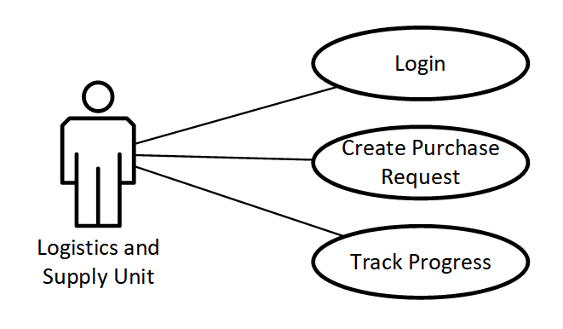
Diagram 2.1 Essential Usecase_Logistics and Supply Unit
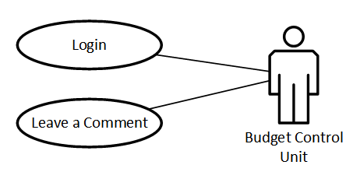
Diagram 2.2 Essential Usecase_Budget Control Unit
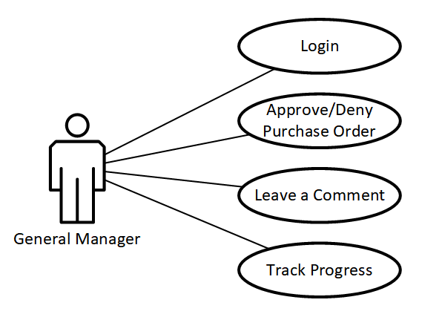
Diagram 2.3 Essential Usecase_General Manager

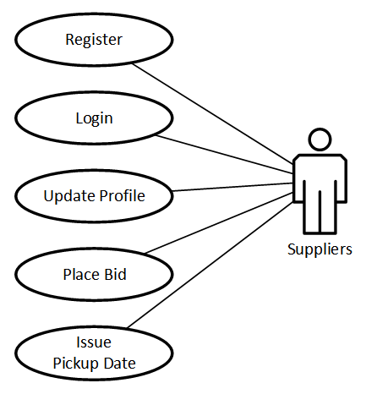
Diagram 2.4 Essential Usecase_Suppliers
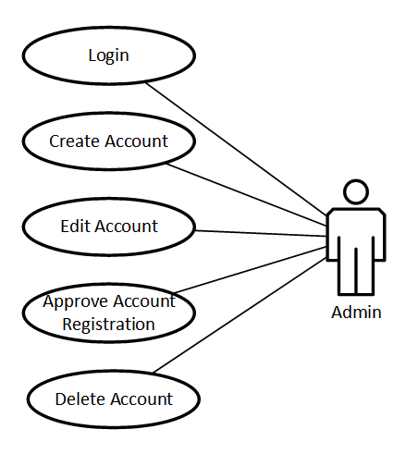
Diagram 2.5 Essential Usecase_Admin

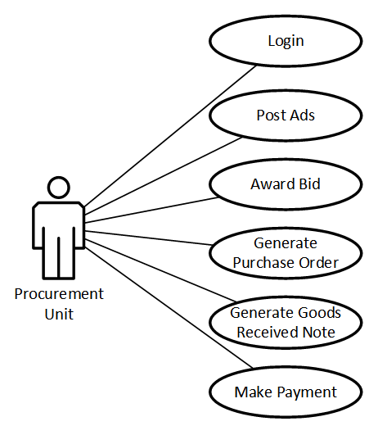
Diagram 2.6 Essential Usecase_Procurement Unit

Actor Identification and Description
ID | Actor Name | Description
A01 | Supply and Logistics Unit | Generate purchase request when stock in inventory is running low or items requested are not in stock.
A01 | Budget Control Unit | Evaluate if the requested items are within budget and give comment
A03 | General Manager | Aprove or deny purchase requests
A04 | Procurement Unit | Post purchase request ads and start the procurement process
A05 | Suppliers | Provide their goods for the company
A06 | Administrator | Control and manage the overall system
Table 2.1 Actor Identification
Supply and Logistics Unit: In Upper Awash Agro Industry every purchase request is generated by these employees. They are commonly refered to as “Store employees” and are found on every processing plant, farm site, and branch offices. All materials and equipments are provided by them. Currently the company has a working inventory system which helps these employees manage stock but when they are running low on specific items they are responsible for managing the submission of purchase requests and ensuring they are accurate and complete before approval. They also follow up on the procurement process and ensure timely delivery of goods to the requesting departments.
Budget Control Unit: Ensures that purchase requests align with the allocated budget. They review requests for financial feasibility and compliance with the organization's budgetary policies. After evaluating, they attach their discovery with the request for the General Manger.
General Manager: Has the final authority to approve or reject purchase requests. The general manager ensures that procurement decisions align with the organization's strategic goals and operational priorities.
Procurement Unit: Handles the end-to-end procurement process, including posting purchase requests, obtaining proforma invoices, evaluating proforma invoices, generating purchase orders, awarding those orders, making payment, upon receiving the goods they generate goods received note, and also maintaining supplier relationships.
Suppliers: External entities that provide goods and services to the organization. They interact with the system to submit proforma invoices, receive purchase orders, and communicate with the procurement unit.
Administrator: Manages system configurations, user roles, and permissions. They ensure the system operates smoothly, handle technical issues, and oversee data security and integrity.

Essential Usecase Description
- Register: Users register or get regitered to they system so they can have role based acces to the system. This role based access allows and restricts them to only interact with functionalities of the system that’s required to them.
- Login: Enables authorized users to access the system with a valid username and password. Role-based permissions determine access to specific functionalities.
- Create Purchase Request: Logistics and Supply Unit users can submit detailed purchase requests, including item descriptions, quantities, and priorities. The system validates the request and forwards it for approval.
- Post Ads on the Web: Approved purchase requests are posted by the Procurement Unit as advertisements, inviting suppliers to place bids. This use case ensures that detailed request information is visible to all suppliers.
- Place Bid: Suppliers submit bids in response to posted advertisements, specifying prices, delivery timelines, and other terms. The system records and timestamps all bids.
- Create Purchase Order: The Procurement Unit generates purchase orders based on approved bids. The order includes supplier details, agreed prices, quantities, and delivery schedules.
- Make Payment: The Procurement Unit processes payments for completed and verified deliveries. The system generates payment records and tracks the transaction status.

Essential User Interface Prototyping (Low Fidelity Prototyping)

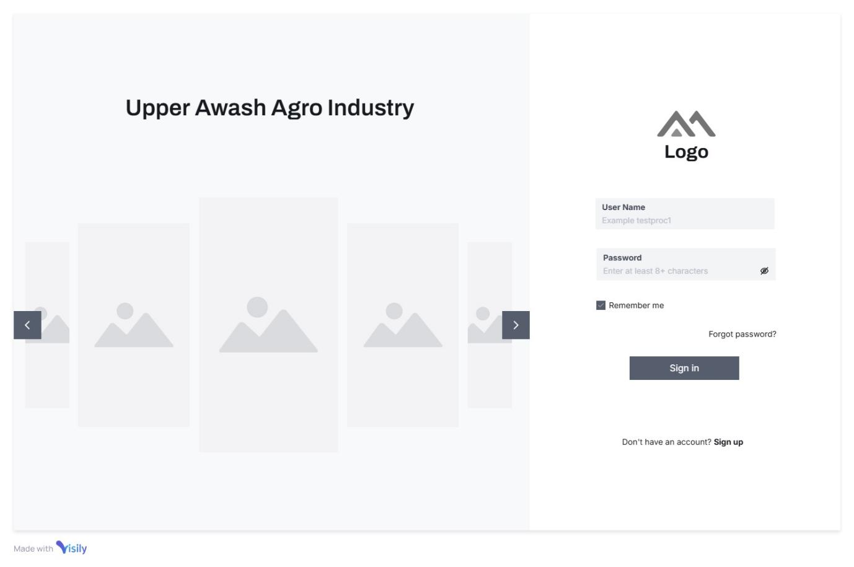
Image 2.2 Essential UI_Login
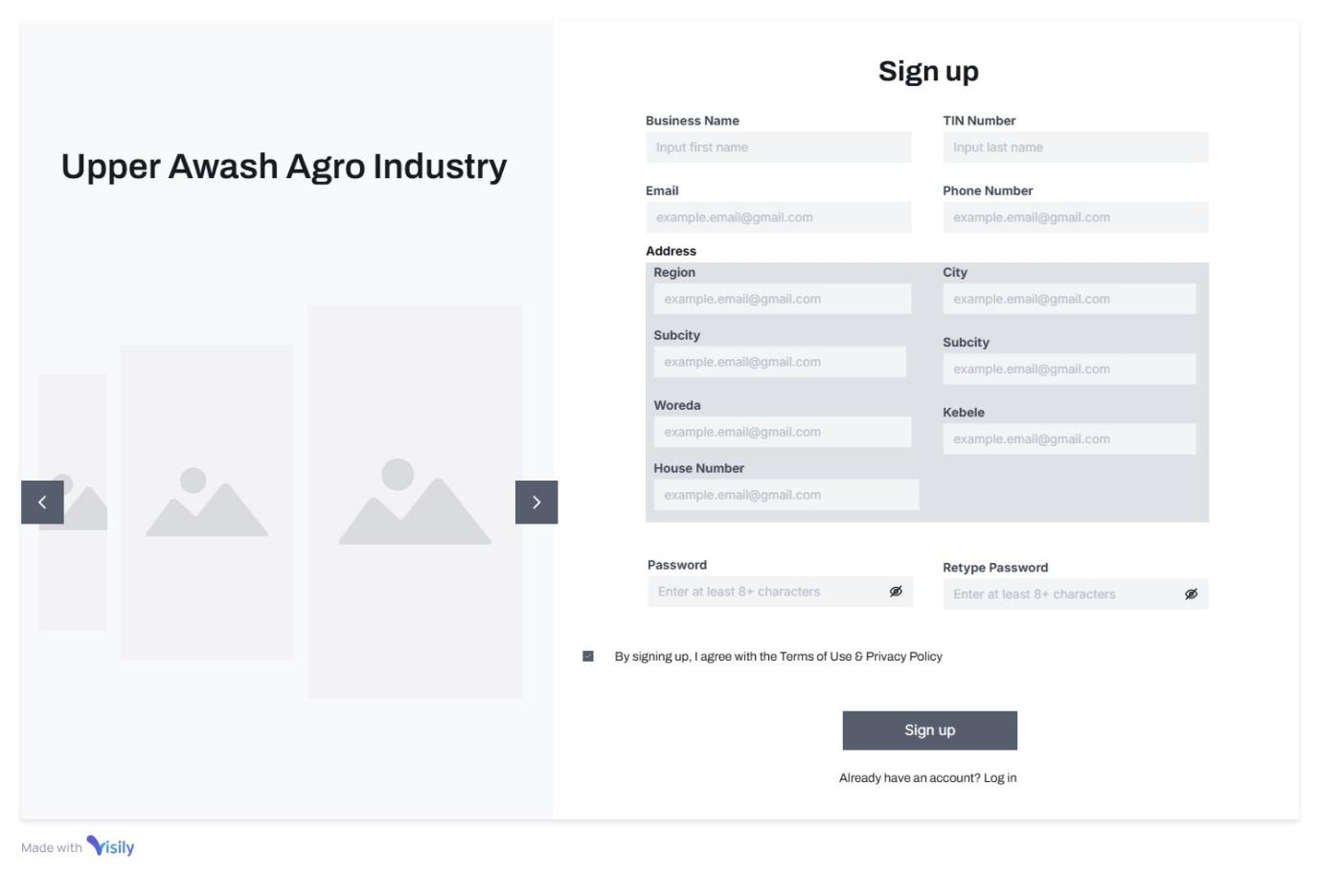
Image 2.3 Essential UI_Supplier Signup

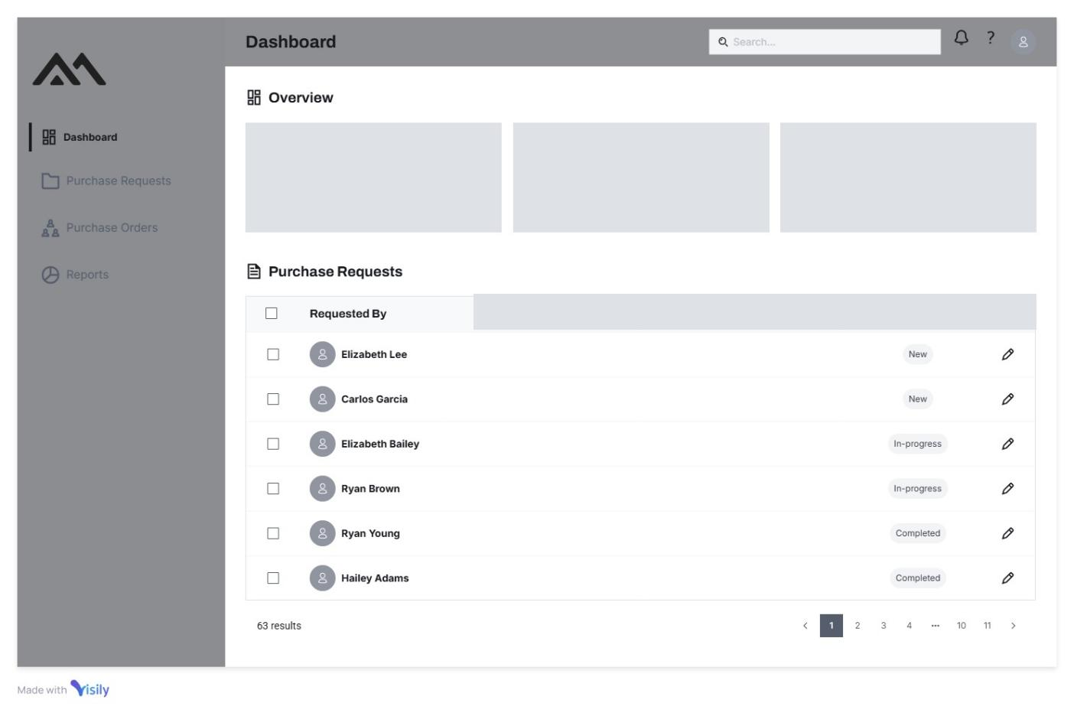
Image 2.4 Essential UI_Procurement Dashboard

Collaboration Modeling
A Collaboration Model defines how actors (users, systems, or external entities) interact within a system to achieve shared goals. It outlines the flow of tasks, responsibilities, and communication channels between stakeholders, ensuring coordinated workflows.
Key Elements of a Collaboration Model
- Actors and Roles: Identifies participants (e.g., Procurement Unit, Suppliers, Admin) and their responsibilities.
- Interaction Scenarios: Describes how actors work together (e.g., a Supplier submitting a bid in response to a Procurement Unit’s posted ad).
- Communication Channels: Defines tools/methods for collaboration (e.g., automated notifications, dashboards, forms).
- Workflow Coordination: Maps handoffs between actors (e.g., purchase request approval by General Manager → bid posting by Procurement Unit).
- Dependencies: Highlights prerequisites for actions (e.g., bids can only be placed after a purchase request is approved).
- Business Rules: Governs interactions (e.g., BR7: Priority rules for awarding bids to sister companies first).

Collaboration Diagrams
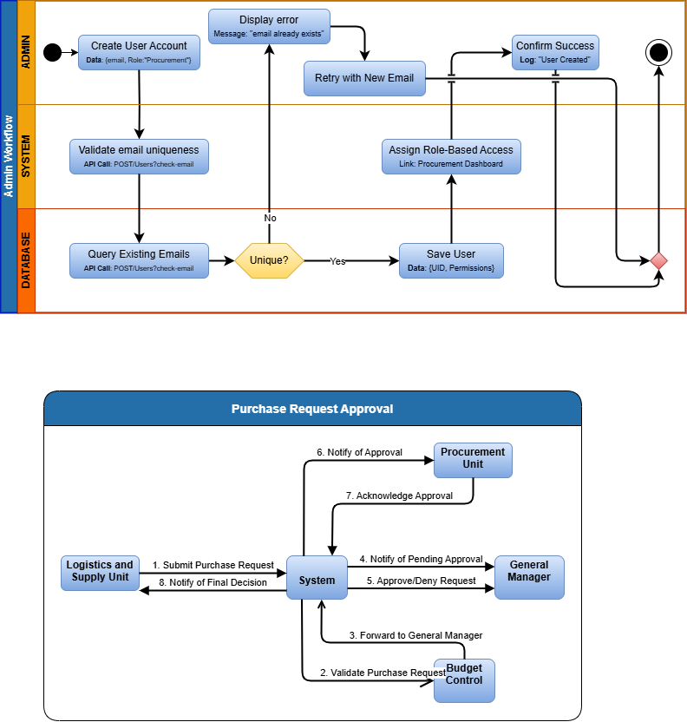
Diagram 2.7 Collaboration Modeling_Purchase Request Approval
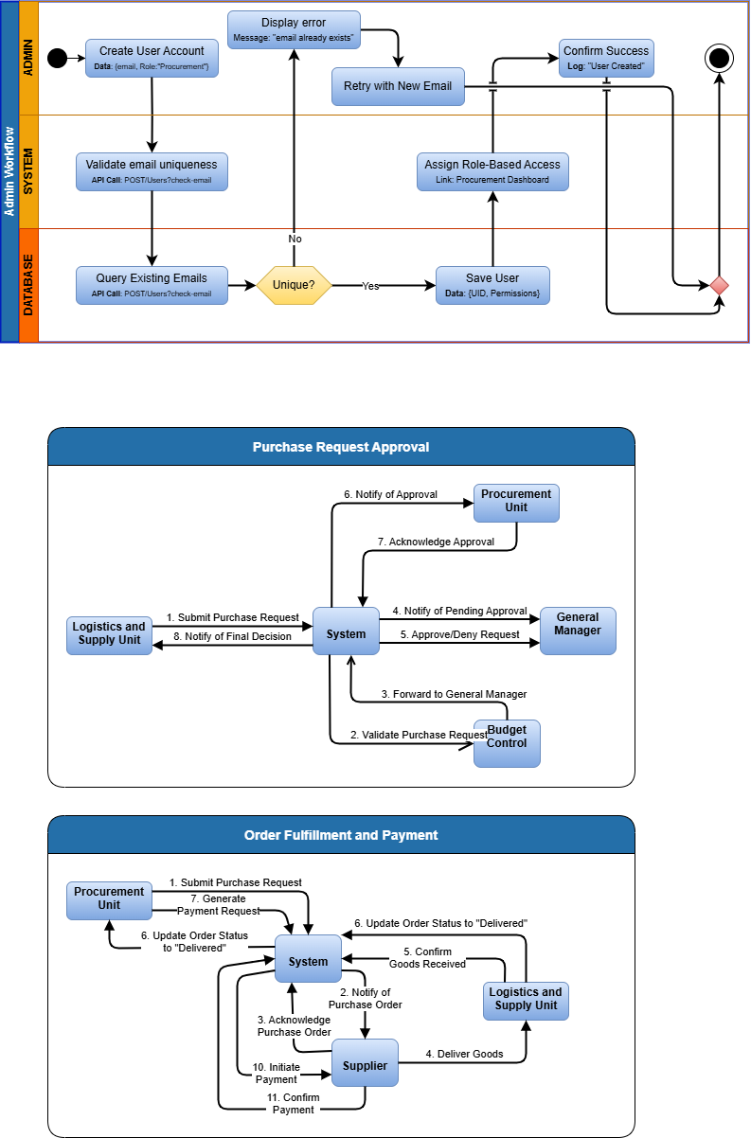
Diagram 2.8 Collaboration Modeling_Order Fulfillment and Payment
Below we used a Swimlane Diagram model to represent the interaction between collaborators. Swimlane Diagrams are flowcharts that show who does what in a process, with each "swimlane" representing a different actor or component. We used this diagram model to show a clearer visualization of responsibilities in our system.
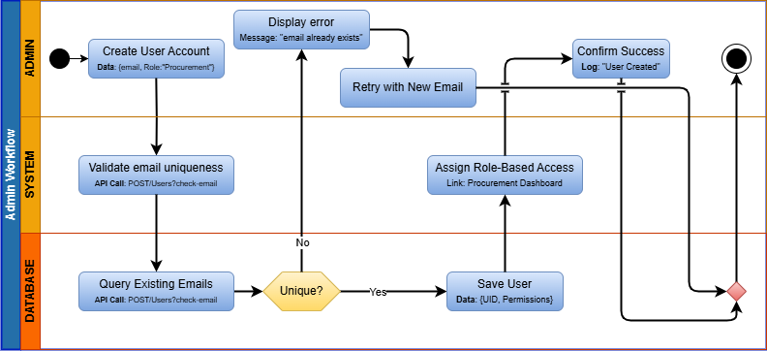
Diagram 2.9 Collaboration Modeling_Admin Workflow

Non-Functional Requirements
Non-functional features are aspects of this systems that define its characteristics and qualities, rather than specific functionalities. These features contribute to the overall performance, usability, and efficiency of the system. Here are some important non-functional features that are often expected in this system.
Non-Functional Requirement | Description
Scalability | The ability to scale the e-PMS system to accommodate growing business needs, whether it's an increase in users, data volume, or transaction volume.
Stability | The system should quickly recover from failures or disruptions, maintaining data integrity and continuing to function correctly
Performance | - Responsive and efficient performance, even under heavyloads or peak times  - Quick response times for user queries and transactions
Reliability and Availability | - High system reliability with minimal downtime  - Ensured availability to support critical business operations24/7
Security | - Robust data security measures to protect sensitiveinformation.  - Access controls and user authentication to ensure dataintegrity
Usability and User Experience | - Intuitive user interfaces that are easy to navigate  - User-friendly design to facilitate user adoption and reduce training time
Data Management and  Integrity | - Data consistency and accuracy across all modules  - Data backup and recovery mechanisms to prevent data loss
Flexibility and Customization | - Ability to customize workflows, reports, and interfaces based on specific business needs  - Support for changes in business processes without disrupting operations
Mobile Accessibility | Support for mobile devices to enable remote access and on- the-go functionality
Training and Support | Adequate training resources and support to assist users in utilizing the e-PMS system effectively
Documentation | Comprehensive documentation for administrators and users
Table 2.2 Non-Functional Requirements

System Modeling

Introduction
This chapter covers the technical aspects of the proposed plant status tracking system and online marketplace, including the identification of the user interface (UI) and business rules. It discusses the design and implementation of the Android and Web UI, as well as the layout, navigation, and visual elements used to create an intuitive and user-friendly interface. Additionally, it highlights the guidelines and requirements that have been established to govern how the system operates and makes decisions, including scalability and flexibility, integration with other systems, and costeffectiveness. It also covers more technical aspects of the system such as Data modeling, use case modeling and Sequence diagrams.
Overall, this chapter provides an in-depth examination of the system modeling process for the proposed plant status tracking system and online marketplace. By understanding the above stated elements and how they interact with one another, it ensures that the system is designed to meet the needs of users and operates effectively and efficiently.

Business Rules Identification
As a business rule, procurement has various rules up on developing the procurement plane and also along the process that the procurement department and suppliers should follow, which are listed below.
Business Rule | Business Rule Identification
BR1 | Bid documents of suppliers should not be open before day in which it is assigned to be opened
BR2 | Upon bid participation the supplier must fill all relative document to completion.
BR3 | The bid will be closed in a given time
BR4 | On preparing procurement documentation for approval, the approval bod is decided with respect to the budget amount all budget approval body have certain level of budget to approve
BR5 | Bid result and status should be visible for suppliers
BR6 | Purchase Orders constitute legally binding contracts. Failure to adhere to the terms and conditions outlined within a Purchase Order may result in penalties imposed upon the non-compliant party, as stipulated by applicable trade laws.
BR7 | PO award precedence:  - Suppliers From Sister Companies  - Manufacturers  - Sole Importers and Distributers  - General Suppliers
Table 2.3 Business Rule Identification

System Use Case Diagram
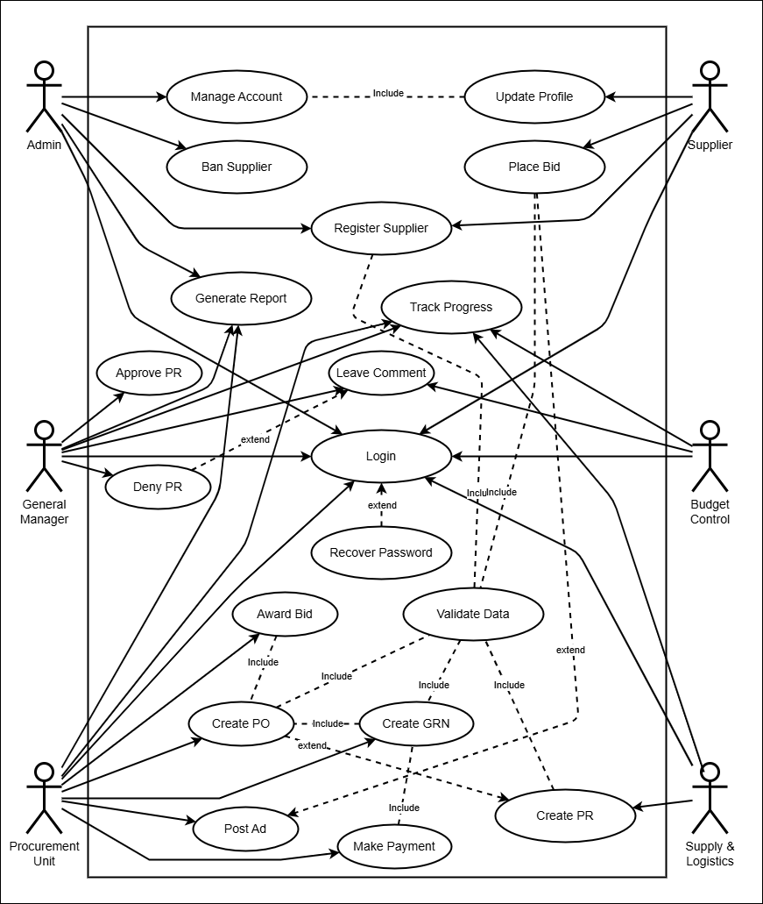
Image 2.5 System Use Case Diagram

Use Case Description
Usecase descriptions are more detailed than essential usecase descriptions and provide a comprehensive overview of the user’s taks and goals. They provide a step by step description of how a user can accomplish a certain task, and include details like pre-conditions, post-conditions, and alternate paths.
Below we’ll see these detailed descriptions:
Usecase Description - Register
Usecase ID | UID-01
Usecase Name | Register
Actor | Supplier
Pre-condition | None
Sequential row | - The user selects registration  - The system display registration interface  - The user enters data to the form and submits it  - The system takes the data and inserts it into the database  - The system will show success message  - Use case ends
Alternative Flow | If the user enters incorrect data the system suggests the user to enter correct data
Post condition | The system confirms registration with a "Registered successfully" message
Table 2.4 Usecase Description _Register
Usecase Description - Create Account
Usecase ID | UID-02
Usecase Name | Create Account
Actor | Admin
Pre-condition | The admin must be logged in with account management privileges
Sequential row | - The admin selects the "Create Account" option  - The system displays an account creation form  - The admin enters the new user's details and submits the form  - The system validates and saves the new account  - Use case ends
Alternative Flow | If entered details are not valid the system prompts the user to enter correct data
Post condition | The new account is successfully created and stored in the system
Table 2.5 Usecase Description_Create Account
Usecase Description - Login
Usecase ID | UID-03
Usecase Name | Login
Actor | General Manager, Admin, Budget Control, Procurement Unit, Supply and Logistics Unit, Supplier
Pre-condition | User account must be registered in the system database
Sequential row | - The user opens the login interface.  - The user enters email and password and login.  - The system will validate ate the email and password.  - The system display user interface  - Use case ends
Alternative Flow | - If the user enters incorrect data  - The system suggests the user to enter correct data.  - If the user exists but the password does not match  - The system suggests the user to enter correct password  - The system suggests user password recovery
Post condition | The user is successfully logged into the system and redirected to their respective dashboard
Table 2.6 Usecase Description _Login

Usecase Description - Create Purchase Request
Usecase ID | UID-04
Usecase Name | Create Purchase Request
Actor | Supply and Logistics Unit
Pre-condition | The user must be logged in and have permission to create purchase requests
Sequential row | - The user selects the "Create Purchase Request" option  - The system displays a form to input request details  - The user enters details such as item description, quantity, and urgency  - The system validates the input and submits the request to the database  - The system displays a success message confirming the request submission  - Use case ends
Alternative Flow | If the user enters invalid or incomplete data the system prompts the user to correct the input and resubmit.
Post condition | The purchase request is successfully created and added to the system.
Table 2.7 Usecase Description _Create PR
Usecase Description - Approve Purchase Request
Usecase ID | UID-05
Usecase Name | Approve Purchase Request
Actor | General Manager
Pre-condition | The purchase request must exist and the user must be logged in with the required approval permissions.
Sequential row | - The user selects a purchase request for review  - The system displays the request details  - The user chooses to approve the request and optionally adds a comment  - The system updates the status of the request in the database  - The system notifies relevant actors about the decision.  - Use case ends.
Alternative | None
Post condition | The purchase request is updated to reflect the approval decision.
Table 2.8 Usecase Description_Approve Purchase Request
Usecase Description - Deny Purchase Request
Usecase ID | UID-06
Usecase Name | Deny Purchase Request
Actor | General Manager
Pre-condition | The purchase request must exist and the user must be logged in with the required approval permissions.
Sequential row | - The user selects a purchase request for review  - The system displays the request details  - The user chooses to approve the request and optionally adds a comment  - The system updates the status of the request in the database  - The system notifies relevant actors about the decision  - Use case ends
Alternative Flow | If the user didn’t fill in a comment to give a reason for the denial, the system will prompt to fill the field and resubmit
Post condition | The purchase request is returned to the Supply and Logistics unit with the comment
Table 2.9 Usecase Description_Deny Purchase Request
Usecase Description - Post Ads
Usecase ID | UID-07
Usecase Name | Post Ads
Actor | Procurement Unit
Pre-condition | The purchase request must be approved, and the user must be logged in with procurement privileges.
Sequential row | - The user selects an approved purchase request  - The system displays a template for posting ads  - The user reviews and customizes the ad details  - The system posts the ad to the website  - The system confirms the ad has been successfully posted  - Use case ends
Alternative Flow | If the user decides the request should be processed in a diferent procedure (i.e. Contracted companies and manufacturers, Imported goods, open auction) then they will proceed on a different avenue
Post condition | The ad for the approved purchase request is visible to suppliers on the website.
Table 2.10 Usecase Description_Post Ads
Usecase Description - Place Bid
Usecase ID | UID-08
Usecase Name | Place Bid
Actor | Suppliers
Pre-condition | The supplier must be registered, logged in, and able to view purchase request ads
Sequential row | - The supplier browses available ads  - The supplier selects an ad and clicks "Place Bid."  - The system displays a bid submission form  - The supplier fills in bid details and submits  - The system records the bid in the database and displays a confirmation message  - Use case ends
Alternative Flow | If the supplier submits incomplete or invalid bid details the system prompts corrections before accepting the bid
Post condition | The bid is successfully submitted and stored in the system for evaluation.
Table 2.11 Usecase Description_Place Bid

Usecase Description - Award Bid
Usecase ID | UID-09
Usecase Name | Award Bid
Actor | Procurement Unit
Pre-condition | Bids must exist for the relevant purchase request, and the user must have the necessary permissions
Sequential row | - The user reviews submitted bids.  - The system displays all relevant bid details.  - The user selects the winning bid and awards it.  - The system updates the status of the purchase request and notifies the winning supplier.  - Use case ends.
Alternative Flow | None
Post condition | The bid is successfully awarded, and the supplier is notified.
Table 2.12 Usecase Description_Award Bid
Usecase Description - Track Progress
Usecase ID | UID-10
Usecase Name | Track Progress
Actor | Procurement Unit, Logistics and Supply Unit, General Manager
Pre-condition | The user must have submitted or approved a purchase request and be logged in
Sequential row | - The user selects the "Track Progress" option  - The system displays a list of active purchase requests  - The user selects a specific request to view detailed progress (e.g., approval status, bid status)  - Use case ends
Alternative Flow | None
Post condition | The user successfully views the current status of the purchase request
Table 2.13 Usecase Description_Track Progress
Usecase Description - Leave a Comment
Usecase ID | UID-11
Usecase Name | Leave a Comment
Actor | Procurement Unit, Logistics and Supply Unit, General Manager
Pre-condition | The user must have submitted or approved a purchase request and be logged in
Sequential row | - The user selects the "Track Progress" option  - Budget Control Unit selects “Purchase Requests List” option  - The system displays a list of active purchase requests  - The user selects a specific request to view the detail of  - The user leaves a comment in the specified location  - Use case ends
Alternative Flow | None
Post condition | The user successfully views the current status of the purchase request
Table 2.14 Usecase Description_Leave a Comment
Usecase Description - Create Purchase Order
Usecase ID | UID-12
Usecase Name | Create Purchase Order
Actor | Procurement Unit
Pre-condition | The bid must be awarded, and the user must be logged in with procurement permissions.
Sequential row | - The user selects an awarded bid  - The system displays the details of the awarded bid  - The user creates a purchase order by confirming the details  - The system saves the purchase order and notifies the supplier  - Use case ends
Alternative Flow | None
Post condition | The purchase order is successfully generated and stored in the system.
Table 2.15 Usecase Description_Create Purchase Order
Usecase Description - Create Goods Received Note
Usecase ID | UID-13
Usecase Name | Create Goods Received Note
Actor | Procurement Unit
Pre-condition | The goods or services must have been received, and the user must be logged in with procurement privileges
Sequential row | - The user selects a completed purchase order  - The system displays the purchase order details  - The user verifies the received goods/services and generates a goods received note  - The system saves the note and updates the purchase order status  - Use case ends
Alternative Flow | None
Post condition | The goods received note is successfully generated and stored in the system
Table 2.16 Usecase Description_Create Goods Received Note
Usecase Description - Delete Account
Usecase ID | UID-14
Usecase Name | Delete Account
Actor | Admin
Pre-condition | The admin must be logged in and the account to be deleted must exist
Sequential row | - The admin selects the "Delete Account" option  - The system displays a list of accounts  - The admin selects an account to delete  - The system prompts for confirmation  - The admin confirms, and the system removes the account  - Use case ends
Alternative Flow | None
Post condition | The account is successfully deleted from the system
Table 2.17 Usecase Description_Delete Account
Usecase Description - Ban Supplier
Usecase ID | UID-15
Usecase Name | Ban Supplier
Actor | Admin, General Manager
Pre-condition | The supplier must be registered in the system, and the user must be logged in with banning privileges
Sequential row | - The user selects the "Suppliers" option  - The system displays a list of registered suppliers  - The user selects a specific supplier  - The system displays details about that specific supplier  - The user selects “Ban Supplier” option  - The system prompts for confirmation with a reason for the ban  - The admin confirms the action and submits the ban request  - The system updates the supplier's status to "Banned" and notifies the supplier of the action  - Use case ends
Alternative Flow | If the admin attempts to ban a non-existent, un-approved or already banned supplier, the system displays an error message
Post condition | The supplier's account is banned, restricting them from accessing the system or placing bids.
Table 2.18 Usecase Description_Ban Supplier
Usecase Description - Make Payment
Usecase ID | UID-16
Usecase Name | Make Payment
Actor | Procurement Unit
Pre-condition | The goods or services must have been received, and the user must be logged in with payment permissions
Sequential row | - The user selects a completed purchase order with a goods received note  - The system displays the payment details  - The user confirms and processes the payment  - The system records the payment and notifies the supplier  - Use case ends
Alternative Flow | None
Post condition | The payment is successfully processed, and the supplier is notified
Table 2.19 Usecase Description_Make Payment

Sequence diagramming
A Sequence Diagram is a type of interaction diagram that shows how objects interact in a particular sequence of time. It details the flow of messages between different objects and actors to accomplish a specific task or part of the functionality within a system. We have used sequence diagrams to analyze the system.
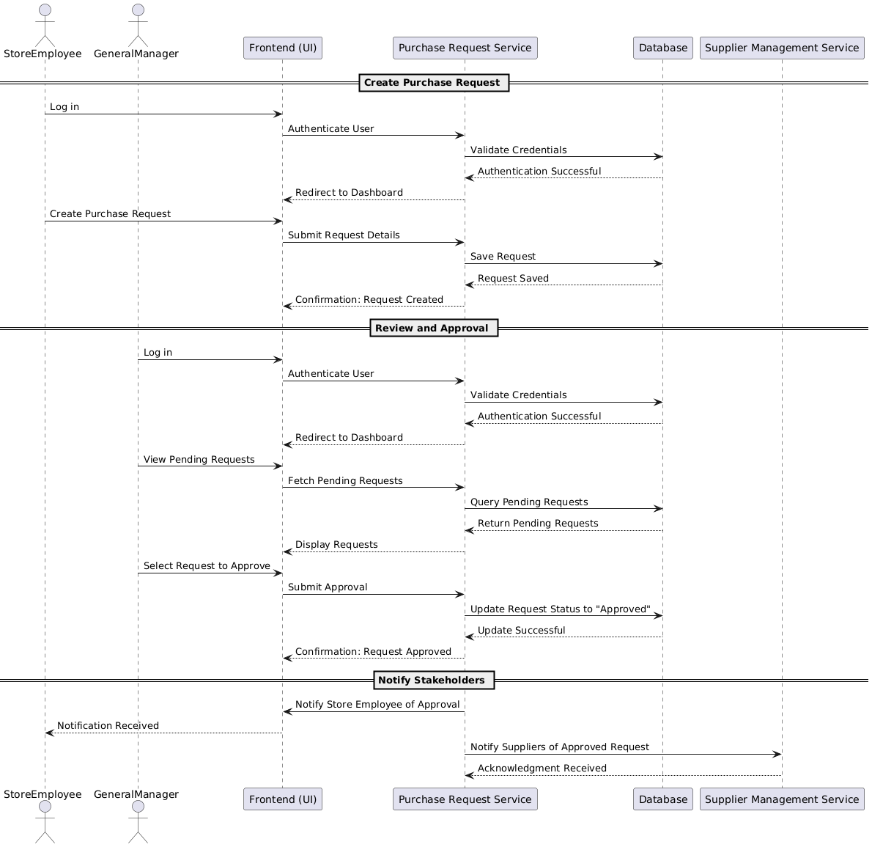
Diagram 2.10 Sequence Diagram_Purchase Request Approval
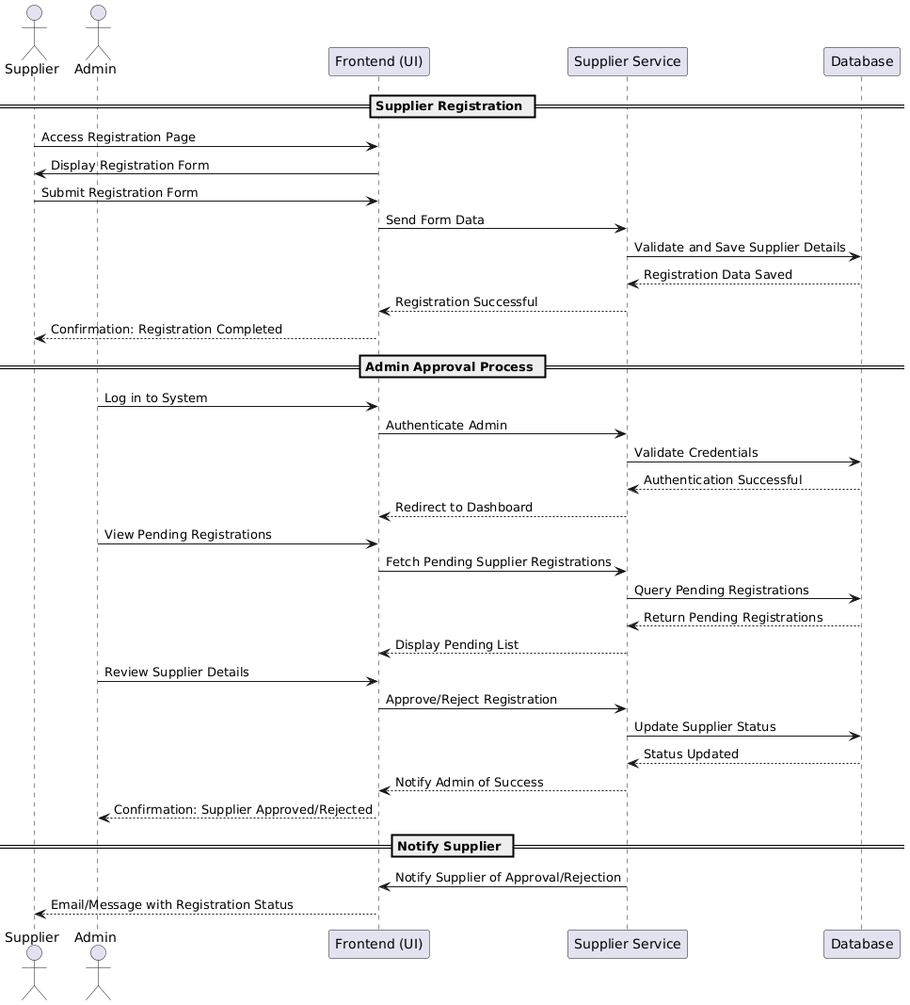
Diagram 2.11 Sequence Diagram_Supplier Registration and Approval
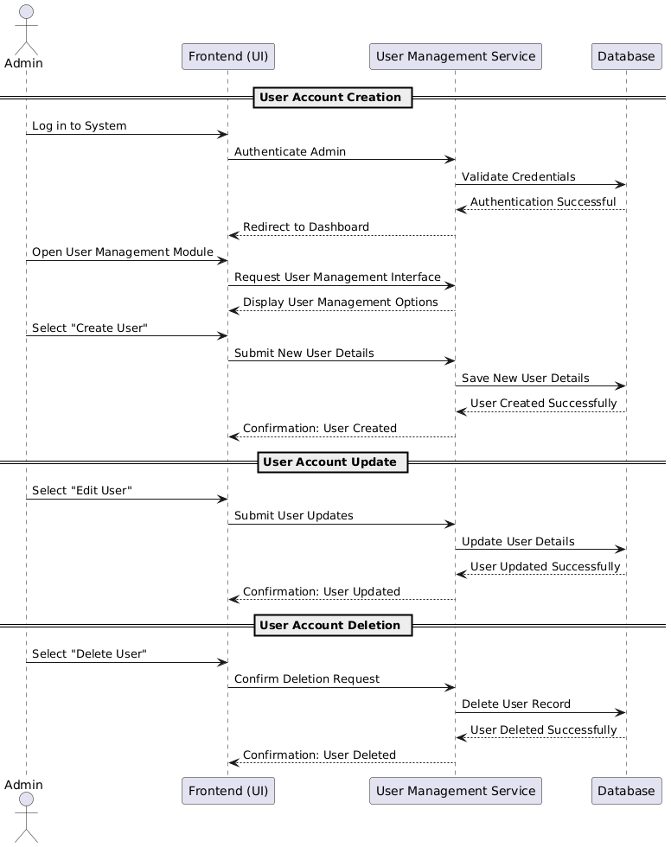
Diagram 2.12 Sequence Diagram_User Management
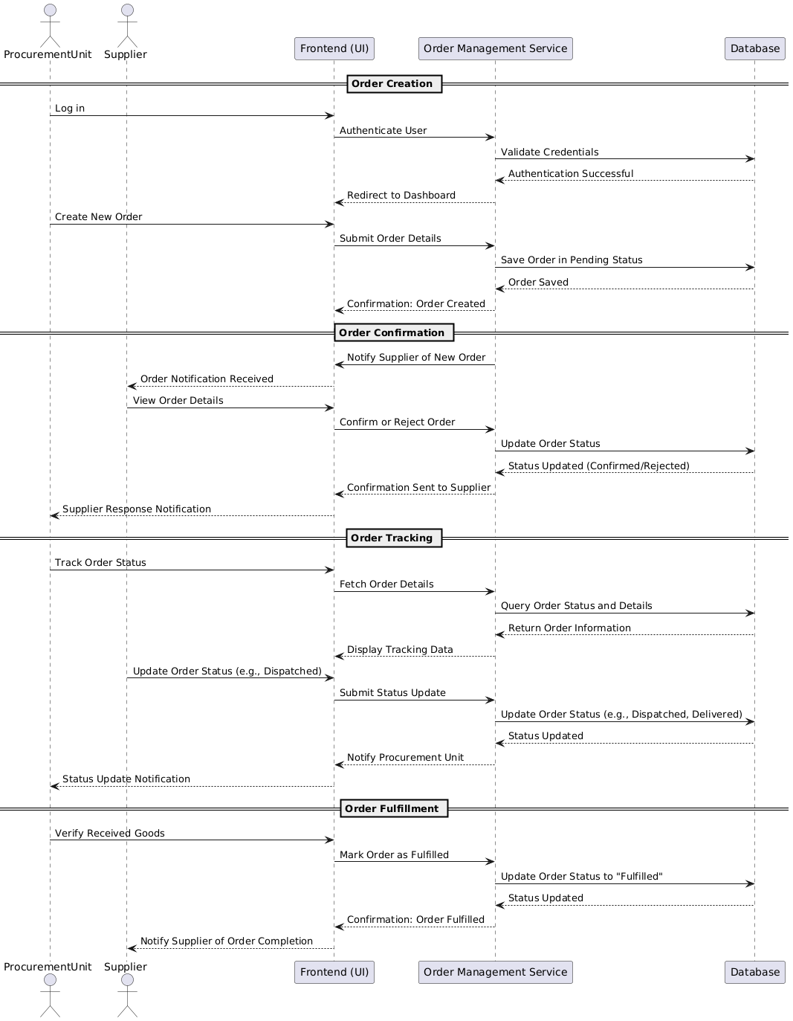
Diagram 2.13 Sequence Diagram_Order Fulfilment and Tracking
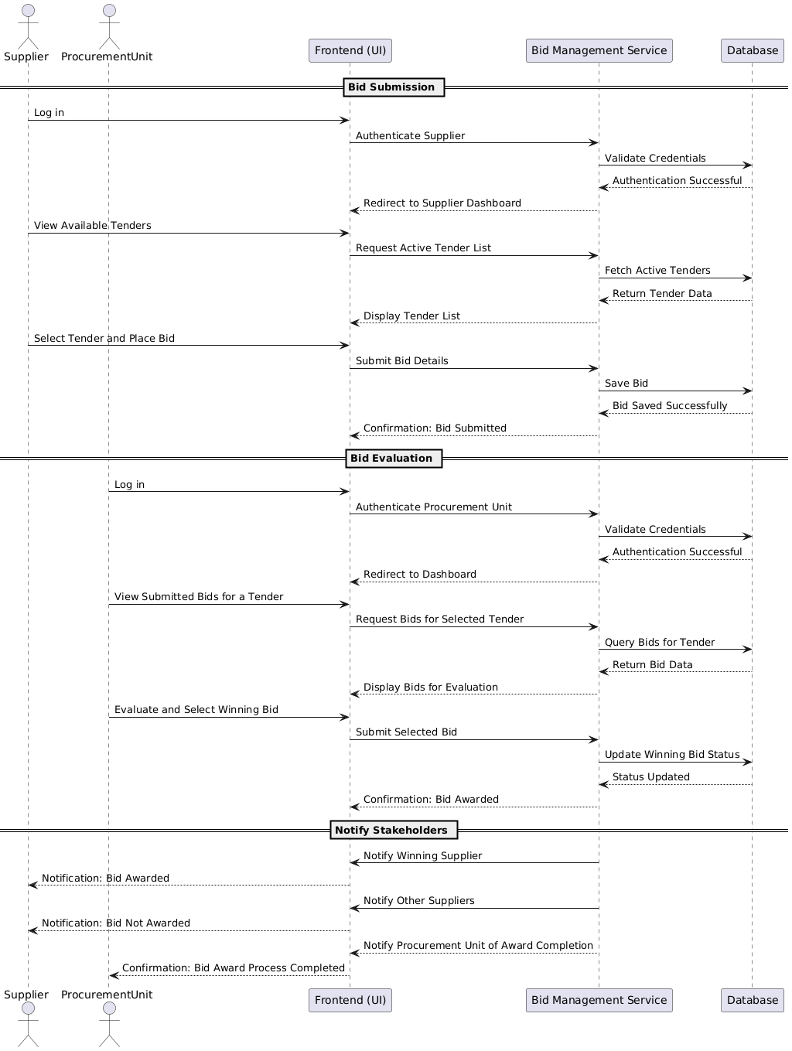
Diagram 2.14 Sequence Diagram_ Bid Submission and Evaluation

Activity Diagram
An activity diagram is a visual representation of the dynamic processes within a system. It outlines the sequence of actions, decisions, and parallel workflows that define how a particular process operates from start to finish. By focusing on the flow of control and data, it provides a clear picture of the operational behavior of a system.
An activity diagram plays a critical role in for our platform ensuring clarity and efficiency. It helps to break down complex processes, such as the approval of purchase requests or bid evaluations, into simpler, step-by-step actions. This makes it easier for stakeholders and developers to understand how the system is expected to behave under various conditions.
The diagrams below are instrumental in identifying potential bottlenecks and inefficiencies within workflows. For example, the centralized approval system currently causing delays can be visualized, enabling us to design solutions to streamline this process. We can design an alternate process to solve this bottleneck and propose it to the involved stakeholders for their approval.
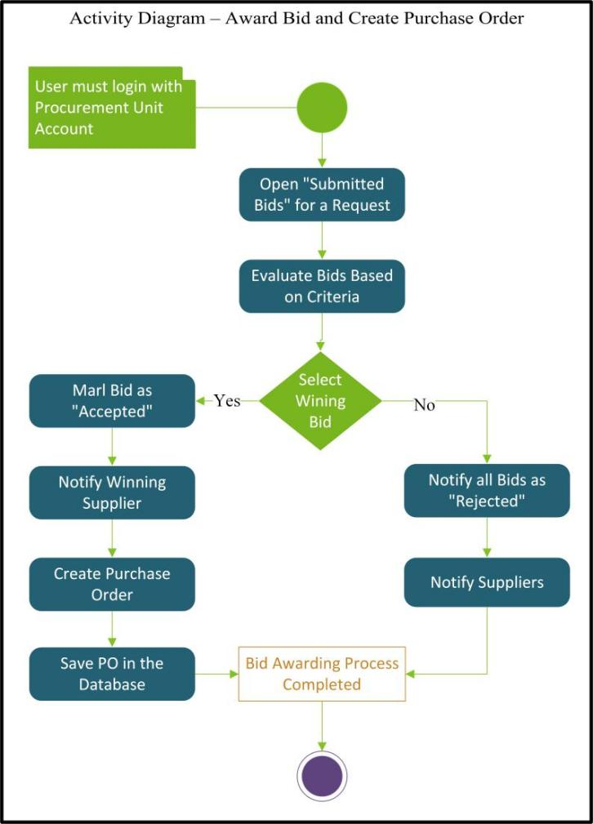
Diagram 2.15 AD_Award Bid & Create PO
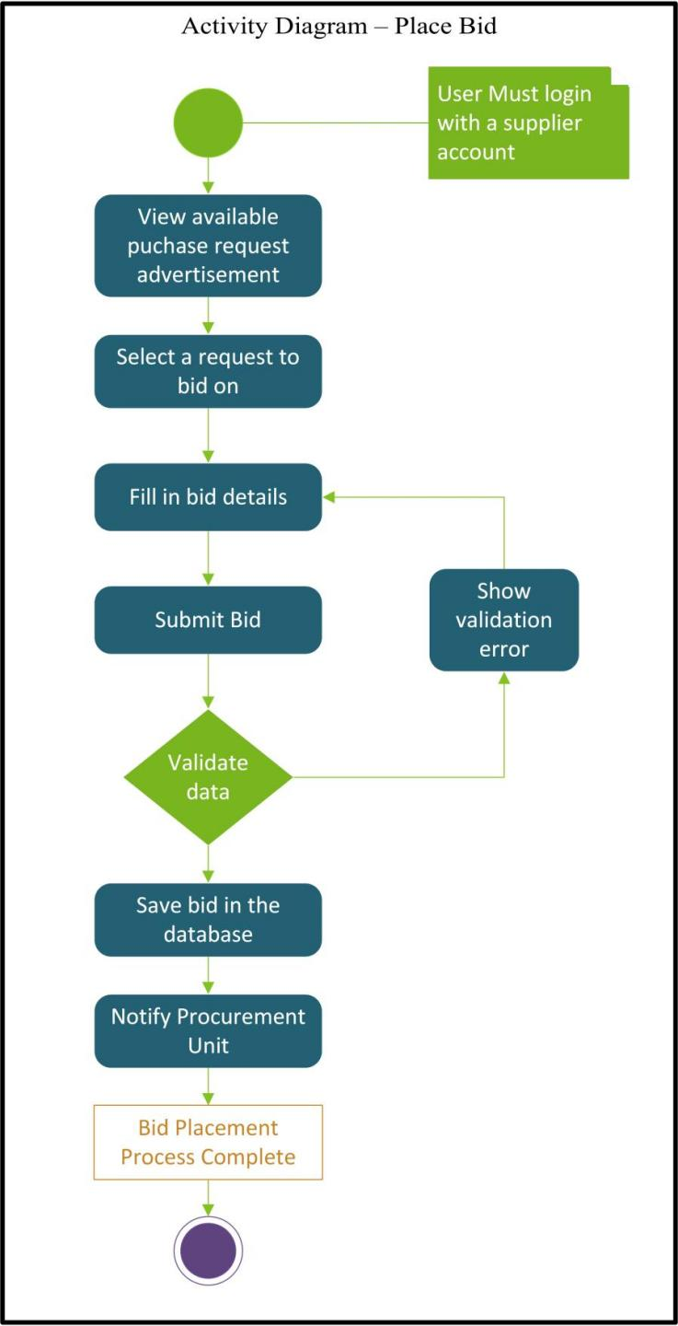
Diagram 2.16 AD_Place Bid

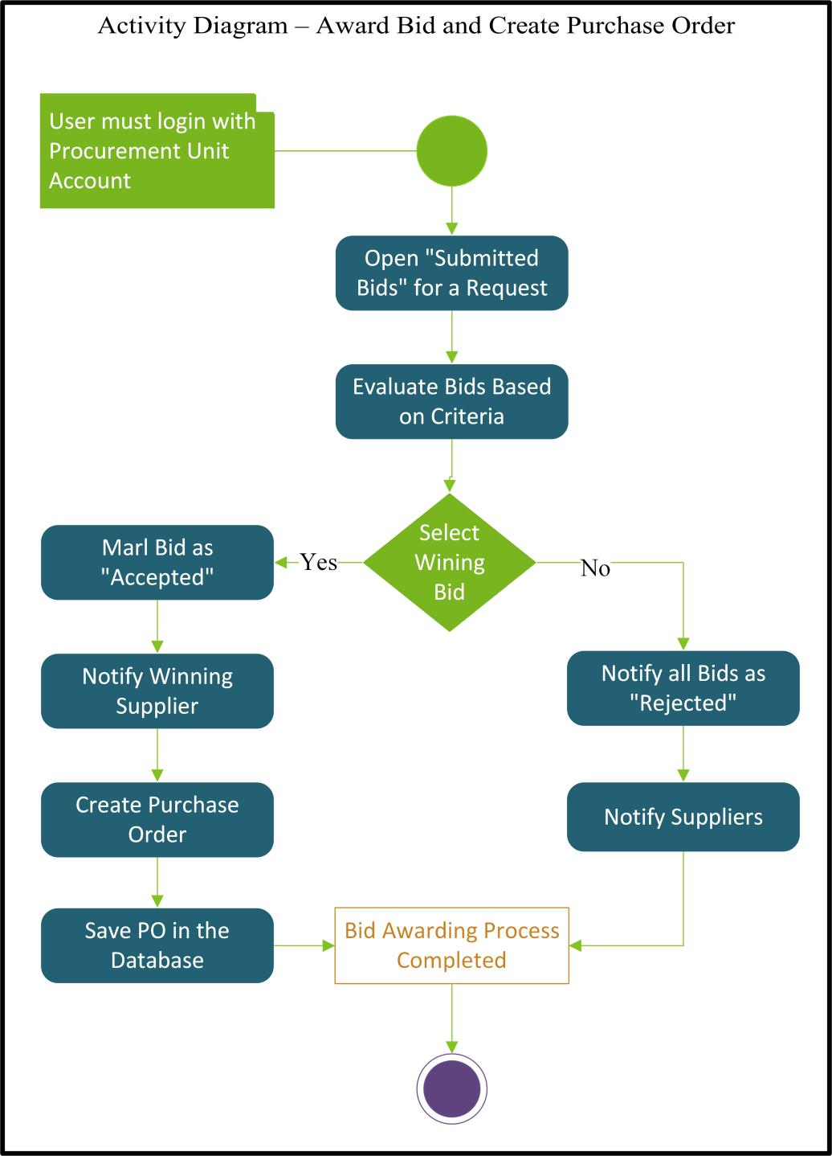
Diagram 2.17 AD_Award bid & PO

Activity diagram generally emphasizes the roles and responsibilities of different actors. It ensures that tasks are appropriately assigned, helping to maintain accountability and smooth collaboration among users like the General Manager, Procurement Unit, and suppliers. This alignment of roles supports a clear division of labor in our system. It also serves as a blueprint for system development. By detailing how data flows and decisions are made, it provides developers with a concrete guide for implementing features. This ensures that the system supports all required processes, reducing errors and ensuring functional consistency across all operations.

Class diagram
A class diagram is a key component of the Unified Modeling Language (UML) that represents the structure of a system by outlining its classes, attributes, methods, and relationships. It acts as a blueprint, illustrating how data flows through the system and how various components interact.
For our platform, the class diagram provides a clear and organized visualization of the system's structure, making it easier to understand the roles and relationships of key entities like users, purchase requests, and bids. This clarity is vital for aligning our development team and stakeholders.
The diagram ensures consistency by explicitly defining attributes and their constraints, such as primary and foreign keys, helping to maintain data integrity in our system. It also guides the technical implementation, ensuring the coding and database design follow the system's conceptual goals.
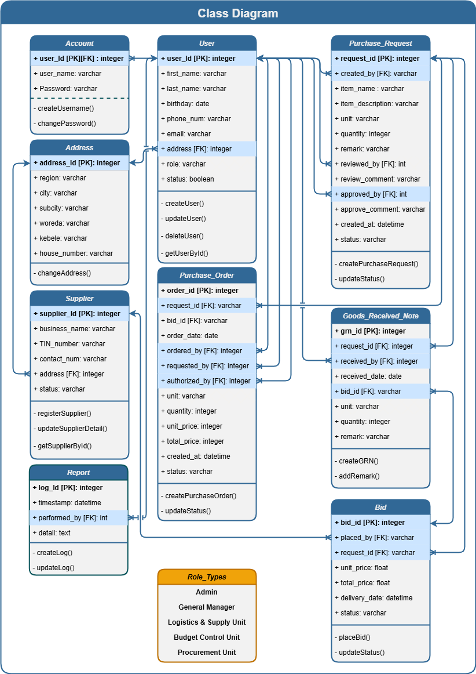
Diagram 2.18 Class Diagram
This class diagram supports scalability by revealing how new features or components, like enhanced supplier management or analytics, can be integrated seamlessly. By serving as a reference point, it aids in maintaining a cohesive system architecture as our project evolves.

State chart diagram
A state chart diagram is a type of behavioral diagram that represents the behavior of a system or object over time. It shows the different states an object or system can be in and the events that cause it to transition between states. State chart diagrams help model the dynamic behavior of a system and understand how it responds to different inputs and events.

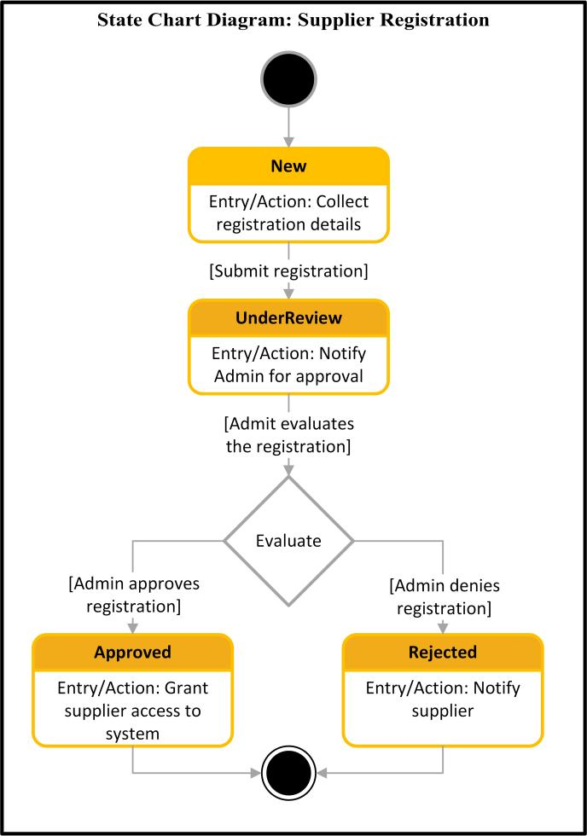  Diagram 2.19 SCD_Supplier Registration | 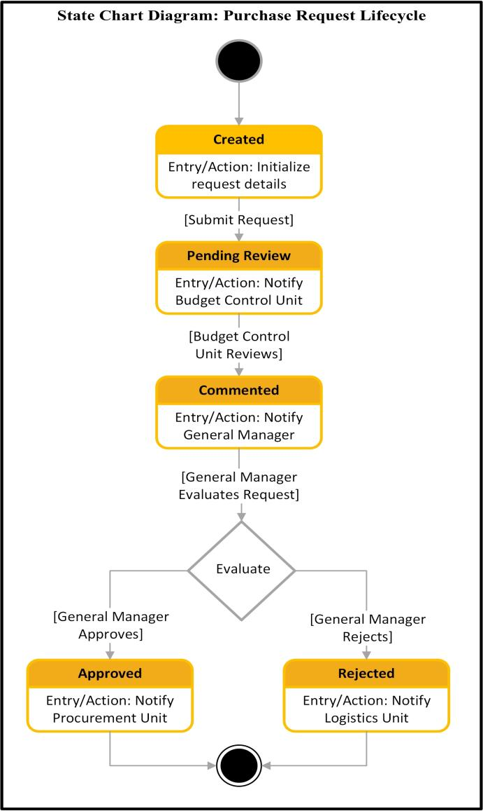  Diagram 2.20 SCD_PR Lifecycle
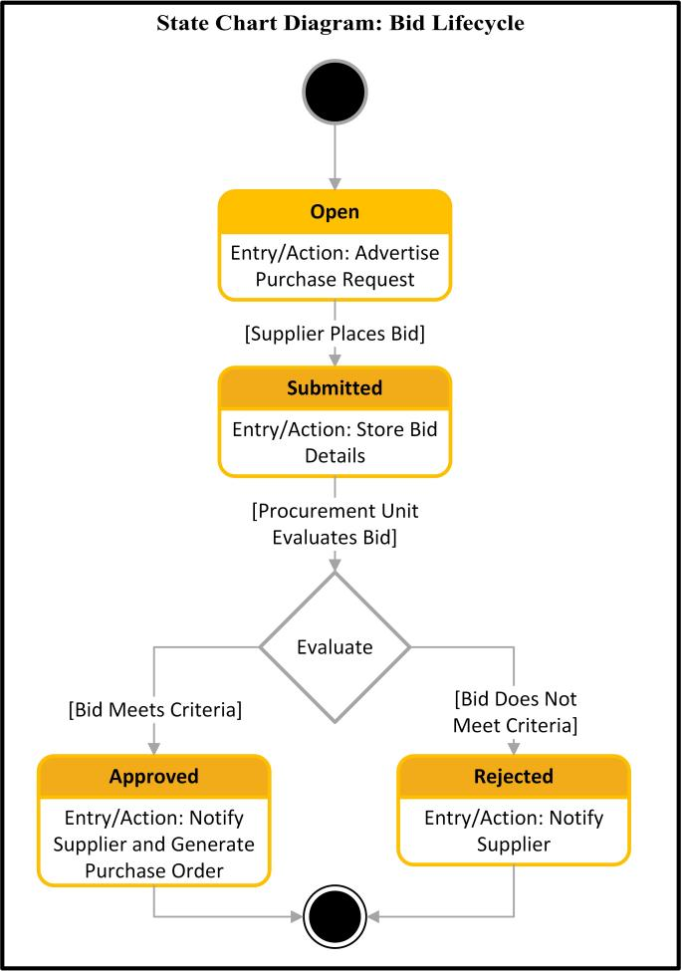  Diagram 2.21 SCD_Bid Lifecycle | 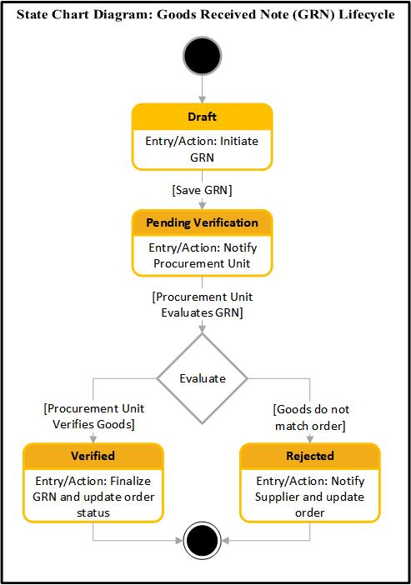  Diagram 2.22 SCD_GRN Lifecycle

User interface Prototyping (High fidelity Prototype)
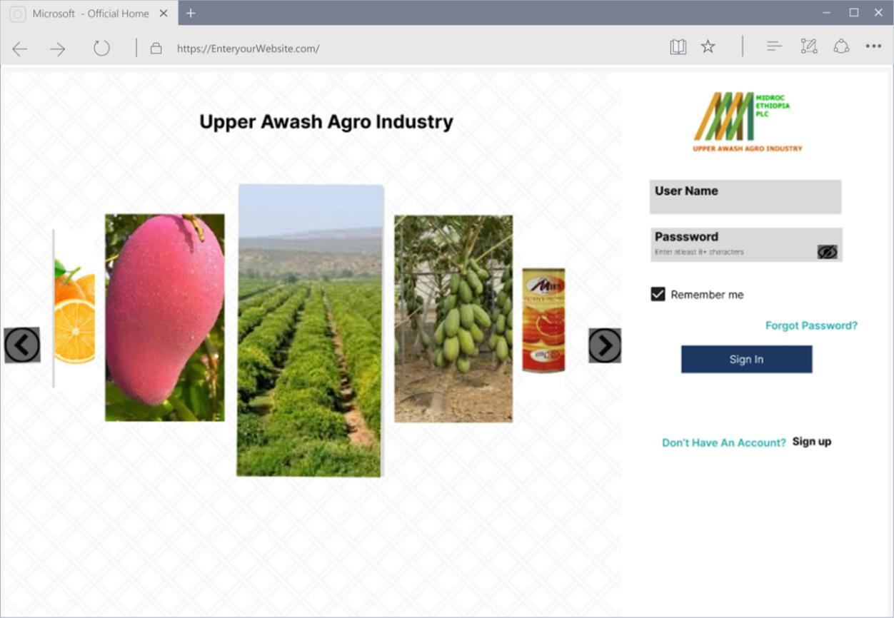
Image 2.6 High Fidelity UI_Login
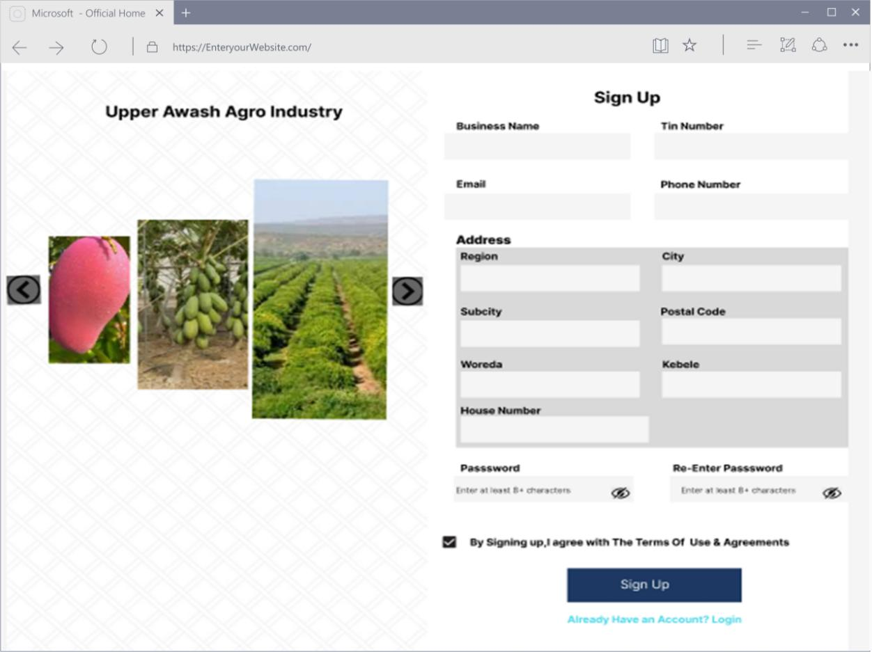
Image 2.7 High Fidelity UI_SignUp
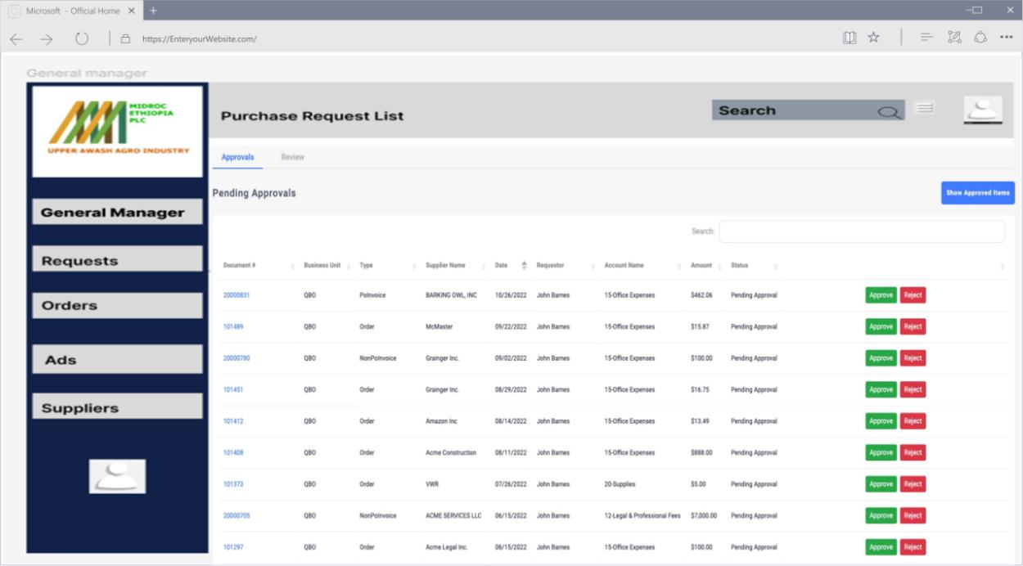
Image 2.8 High Fidelity UI_GM Review Request

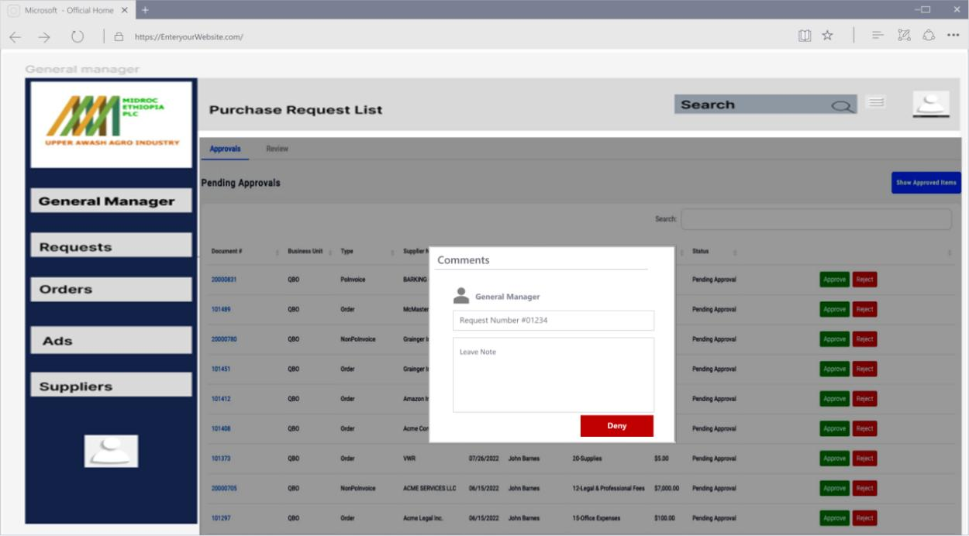
Image 2.9 High Fidelity UI_GM Comment and Deny Request
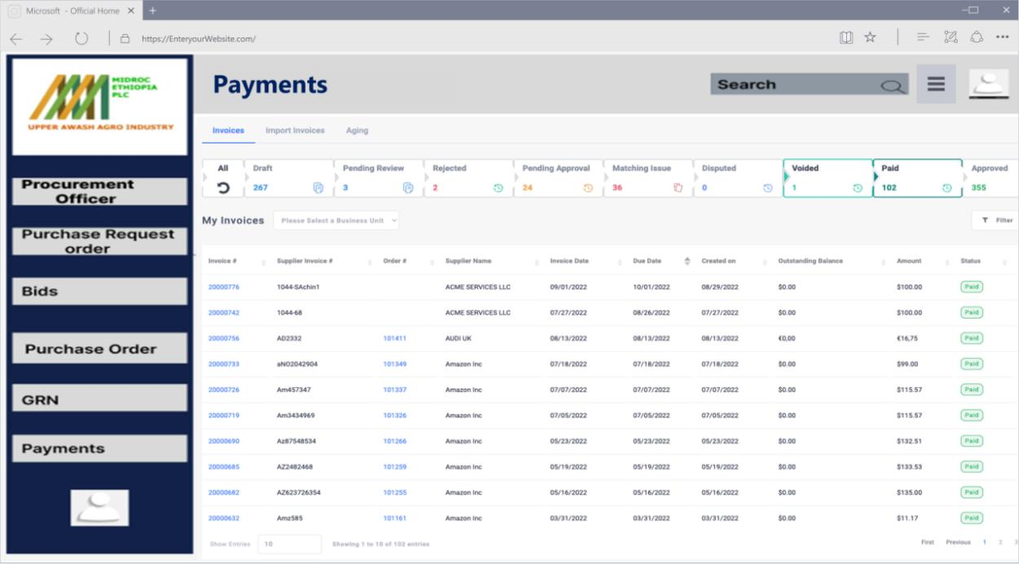
Image 2.10 High Fidelity UI_Procurement Unit View Payment History

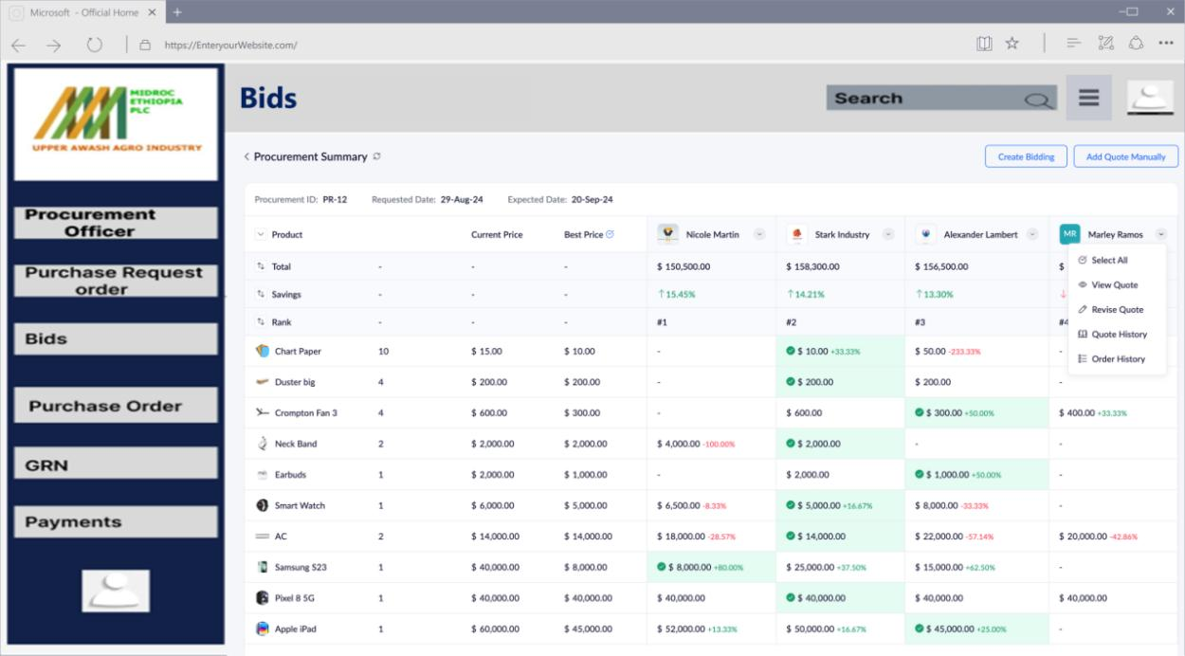
Image 2.11 High Fidelity UI_Procurement Unit Evaluate Bids

CHAPTER - III

System Design

Introduction
This section provides an in-depth overview of the system design for the Web-Based Purchase Order Management System developed for Upper Awash Agro Industry. The system design encompasses the translation of the project’s requirements into a technical blueprint, ensuring functionality, scalability, and alignment with organizational goals. This document aims to establish the foundation for building a robust and efficient platform tailored to address the challenges in the procurement process.
System design is structured around key components: architecture, data models, subsystems, and security measures. These components collectively form the backbone of the system, guiding developers in implementing a solution that meets both functional and non-functional requirements.

Purpose of the System
The primary purpose of the Web-Based Purchase Order Management System is to modernize and streamline the procurement processes of Upper Awash Agro Industry. By transitioning from a manual, paper-based system to a centralized, digital platform, the organization can achieve the following objectives:
- Automation: Eliminate repetitive manual tasks and reduce human error
- Transparency: Enhance visibility into procurement activities, ensuring accountability at every stage
- Efficiency: Shorten approval cycles and improve communication with suppliers
- Scalability: Accommodate organizational growth and increasing procurement needs
- Data-Driven Decisions: Provide actionable insights through reporting and analytics to support strategic planning
The system aspires to bridge gaps in existing workflows, fostering improved collaboration among employees, suppliers, and decision-makers

Design Goals
To achieve its objectives, the system design adheres to the following principles:
- Maximize Usability: The system presents a user-friendly interface designed to meet the needs of all users, from employees to procurement officers and suppliers. This Simple design ensures that even those with limited technical skills can easily navigate the system. Workflows are streamlined to minimize unnecessary steps, allowing users to efficiently create purchase requests, track orders, and complete approvals. Furthermore, customized dashboards provide each user with the specific information and tasks relevant to their role, enhancing productivity and satisfaction.
- Enhance Security and Data Integrity: Robust security measures, including strong password requirements, safeguard access to the system. Sensitive information, such as financial data and user credentials, is encrypted to prevent unauthorized access.
- Optimize System Performance and Scalability: The system employs an efficient architecture optimized to handle a large number of users and data. Technologies such as caching and optimized database queries contribute to excellent performance. Rigorous performance testing identifies and addresses potential bottlenecks, ensuring the system remains responsive under various load conditions. Moreover, the system is designed to scale, allowing for the dynamic allocation of resources to accommodate periods of high demand.
- Ensure Reliability and Availability: Redundant servers and automatic failover mechanisms ensure continuous service, even in the event of hardware or software failures. Automated and incremental backups will protect against data loss due to system crashes or human error. These backups will be stored securely and tested periodically for recovery effectiveness.
- Support Maintainability and Extensibility: The system will be divided into self-contained modules, such as user management, procurement workflows, and supplier management. This allows developers to make updates or add features without impacting unrelated parts of the system. Detailed documentation will accompany the system, covering the architecture, APIs, and user workflows. This ensures a smooth handover to maintenance teams and facilitates training for end-users.

Proposed Software Architecture
The architecture of the Web-Based Purchase Order Management System follows a three-tier model, which separates concerns into three distinct layers: frontend, backend, and data management. This modular approach ensures scalability, maintainability, and flexibility, enabling the system to grow alongside organizational needs. The frontend focuses on user interactions, the backend handles application logic and workflows, and the data layer manages persistent storage and retrieval.
- Frontend Layer: using HTML, CSS, JavaScript, and Laravel Blade templates, it a responsive and user-friendly interface for interacting with the system. This layer is responsible for delivering dynamic and role-specific content to users, ensuring an intuitive experience across devices. It presents features like:
  - User authentication and role-based navigation to guide users to relevant features.
  - Interactive dashboards for procurement officers and suppliers that provide actionable insights at a glance.
  - Input validation mechanisms to prevent erroneous data from entering the system.
- Backend Layer: Using PHP technology with Laravel Framework, it acts as the core engine of the system, processing business logic and orchestrating communication between the frontend and data layers:
  - Ensures secure login and defines access levels for users based on their roles.
  - Automates the creation, submission, and multi-level approval of purchase requests.
  - Streamlines supplier registration and evaluates bids against predefined criteria.
  - Tracks order lifecycles and integrates with payment gateways for seamless transactions.
- Data Layer: Using SQL Database, it serves as the repository for all system data, ensuring reliability and consistency in storage and retrieval.
  - The schema design is tailored to manage procurement data such as users, purchase requests, bids, and orders. Relationships between tables ensure data integrity.
  - Backup and Recovery Protocols Protects against data loss by implementing scheduled backups and disaster recovery mechanisms.
  - Query Optimization Enhances system performance by indexing frequently queried fields and using efficient SQL queries.
Addressing Design Goals and Requirements
The proposed architecture has been meticulously crafted to meet the system’s design goals and requirements:
- Usability: A role-specific frontend ensures users can easily access their tasks and information. Simplified workflows and validation mechanisms enhance the overall user experience.
- Security and Data Integrity: Robust authentication and authorization mechanisms in the backend prevent unauthorized access.Encryption ensures sensitive data remains secure, while audit trails provide transparency and accountability.
- Performance and Scalability: The modular architecture allows independent scaling of each layer based on demand, ensuring consistent performance even during high traffic. Caching and optimized database queries minimize latency and enhance responsiveness.
- Reliability and Availability: Redundant systems and failover mechanisms in the backend ensure minimal downtime. Real-time monitoring tools proactively identify and resolve issues.
- Maintainability and Extensibility: The use of Laravel’s MVC framework encourages a clean codebase, making updates and feature additions straightforward. Comprehensive documentation supports future developers and maintenance teams, enabling seamless transitions and upgrades.

Subsystem Decomposition
To ensure efficient development and system scalability, the platform is divided into several distinct subsystems, each with specific roles and responsibilities.
User Management Subsystem
The User Management Subsystem is responsible for handling all aspects of user accounts, including their creation, authentication, and authorization. This subsystem ensures secure access to the system and supports role-based permissions, allowing administrators to control which features are accessible to different user groups. Key functionalities include registration, login, profile management, and role assignment. The modular nature of this subsystem ensures scalability as the organization grows, allowing for easy addition of new roles or permissions as required.
Procurement Workflow Subsystem
The Procurement Workflow Subsystem automates the creation, tracking, and approval of purchase requests. It provides tools for employees to initiate requests, track their progress, and ensure they go through the necessary approval hierarchy. Notifications and escalation mechanisms are integrated to alert users of pending tasks and expedite approvals when delays occur. This subsystem streamlines procurement processes, reducing inefficiencies and ensuring timely execution of requests.
Supplier Management Subsystem
The Supplier Management Subsystem facilitates the registration and onboarding of suppliers, as well as their interactions with the organization. This includes maintaining supplier profiles, providing a portal for bid submissions, and tracking supplier performance over time. By offering a centralized platform for managing supplier-related activities, this subsystem ensures that the procurement team can easily evaluate and engage with suppliers, promoting transparency and competitiveness in the bidding process.
Order Fulfillment Subsystem
The Order Fulfillment Subsystem manages the lifecycle of purchase orders from initiation to completion. It tracks the status of orders, facilitates communication between stakeholders, and ensures timely delivery of goods or services. Once an order is fulfilled, the subsystem generates reports for auditing and performance evaluation. By centralizing order management, this subsystem helps maintain accountability and improves the reliability of procurement operations.
Reporting and Analytics Subsystem
The Reporting and Analytics Subsystem provides decision-makers with real-time insights into procurement activities. Customizable dashboards allow users to monitor key metrics such as request approval times, supplier performance, and budget utilization. Exportable reports support detailed analysis and long-term planning. This subsystem plays a crucial role in enabling data-driven decision-making, ensuring that the organization’s procurement strategies align with its operational goals.

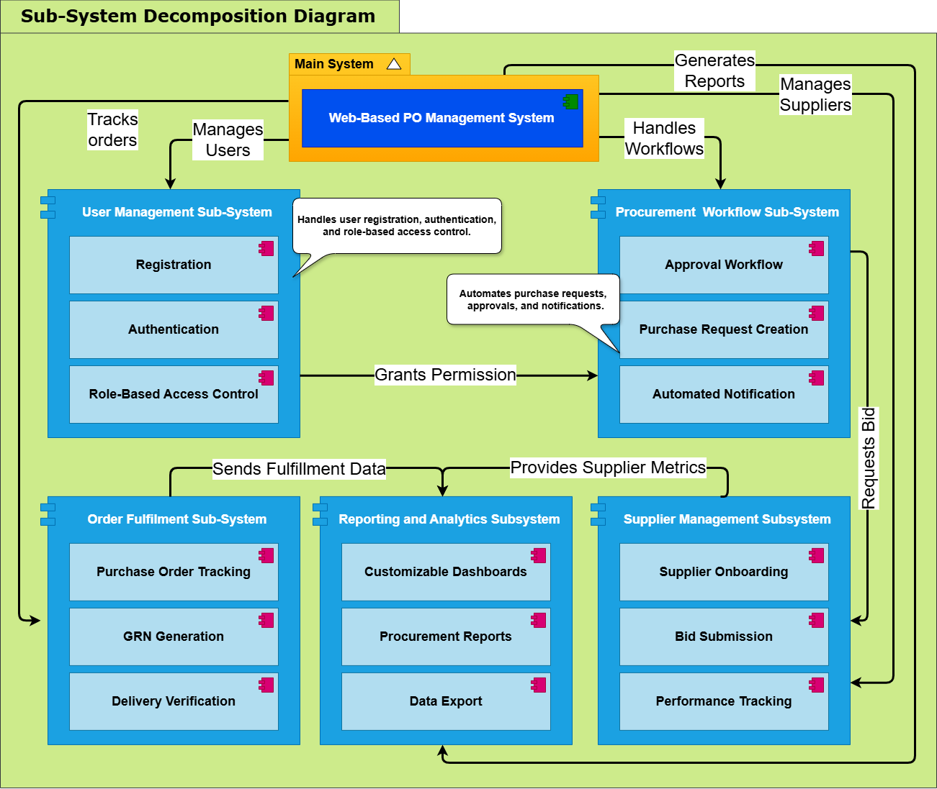
Diagram 3.1 Sub-System Decomposition Diagram

Component Diagram
A component diagram is a type of UML (Unified Modeling Language) diagram that illustrates the organization and interrelationships of the components within a system. Components represent modular parts of the system that encapsulate behavior and data, making it easier to manage complex software architectures.
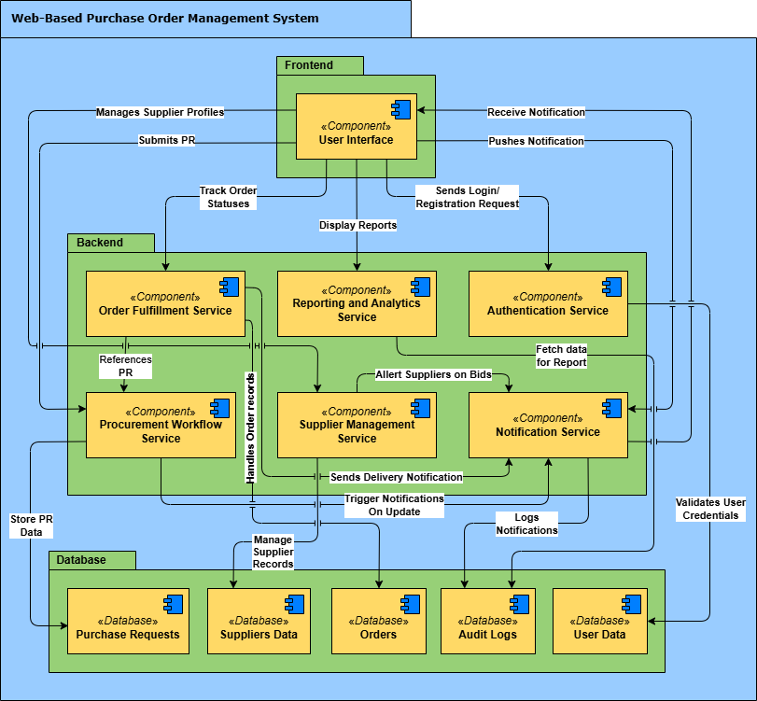
Diagram 3.2 Component Diagram

Deployment Diagram
A deployment diagram is a type of UML (Unified Modeling Language) diagram that shows the physical deployment of artifacts (software components, hardware nodes, etc.) on nodes (hardware devices, execution environments). It depicts a system's hardware and software configuration, showing how the software components are deployed on the hardware infrastructure.
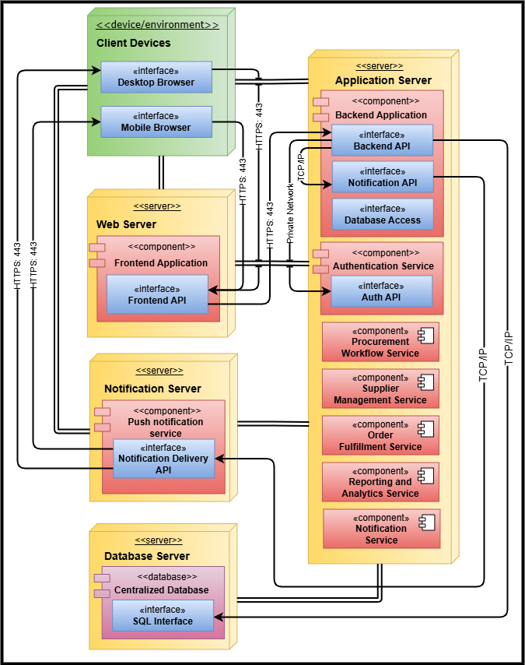
Diagram 3.3 Deployment Diagram

Persistent Data Management
Persistent data management is a cornerstone of the Web-Based Purchase Order Management System, ensuring that all critical data is reliably stored, managed, and accessed. The system handles various types of data, including user information, procurement records, supplier details, transaction histories, and supporting documents such as invoices and receipts.
- Database Technology and Storage Mechanisms: The system utilizes a relational database management system (RDBMS), specifically Microsoft SQL Server, to store structured data. This choice ensures robust data consistency, scalability, and support for complex queries. Document files, such as invoices and receipts, are stored in a secure file storage system integrated with the database through references.
- Data Access Methods: Access to data is facilitated through APIs that provide a secure and efficient mechanism for retrieving, updating, and managing data. These APIs enforce role-based access to ensure users only interact with data relevant to their responsibilities. Query optimization and indexing are employed to enhance performance, especially for frequently accessed records.
- Data Backup and Recovery: To protect against data loss, the system implements automated backups at regular intervals. These backups are stored in secure, geographically distributed locations to ensure disaster recovery capabilities. Incremental backup strategies minimize storage overhead while allowing quick recovery of specific data subsets. Periodic recovery tests validate the reliability of backup processes.
- Data Integrity: Data integrity is maintained through mechanisms such as transaction management, which ensures that operations affecting multiple data entities are executed completely or rolled back if an error occurs. Additionally, hashing techniques verify that records have not been tampered with, preserving trust in the system’s data.

Detailed Database Design
This section outlines the database structure for the Web-Based Purchase Order Management System, including relational tables, normalization, entity-relationship modeling, and security considerations.

Relational tables
The database comprises the following tables to support procurement workflows, user management, and supplier interactions:
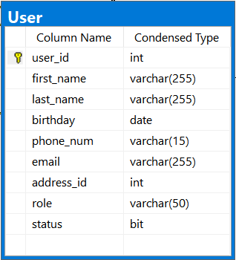  Table 3.1 Relational Table_User | 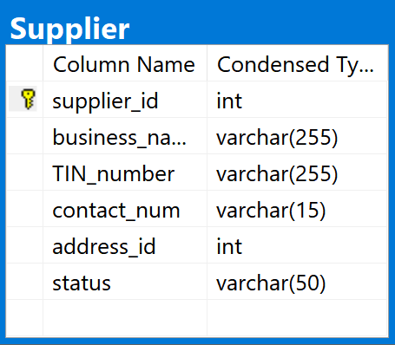  Table 3.2 Relational Table_Supplier
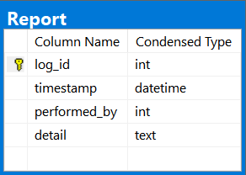  Table 3.3 Relational Table_Report | 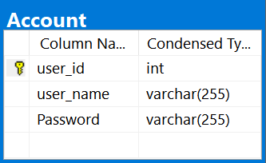  Table 3.4 Relational Table_Account
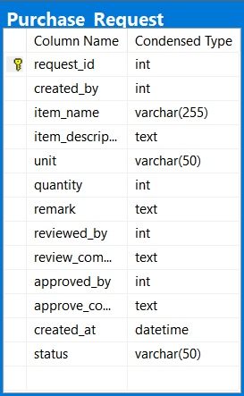  Table 3.5 Relational Table_Purchase Request | 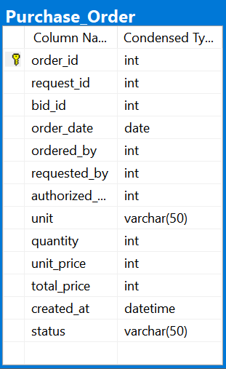  Table 3.6 Relational Table_Purchase Order
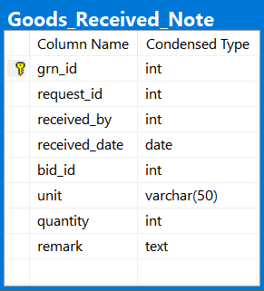  Table 3.7 Relational Table_GRN | 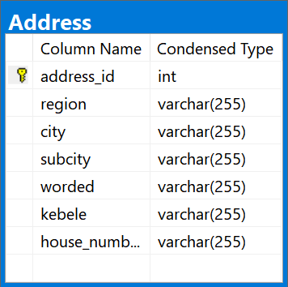  Table 3.8 Relational Table_Address
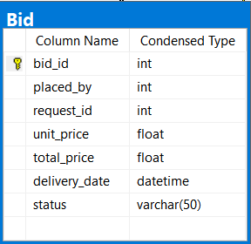  Table 3.9 Relational Table_Bid | 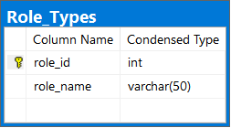  Table 3.10 Relatinal Table_Role Types

Normalization
This section outlines the normalization process applied to the database tables of the Web-Based Purchase Order Management System. Normalization ensures data integrity, eliminates redundancy, and organizes data into logical structures. Tables are normalized up to the Third Normal Form (3NF) where necessary. Below are examples of key tables and their normalization steps:
PurchaseRequests Table (Unnormalized)
RequestID | UserID | ItemDescription | Quantity | UnitOfMeasure | UrgencyLevel | BudgetCategory | Status | CreatedAt
101 | 25 | Fertilizer | 500 | Kg | High | Farm Supplies | Pending | 2025-01-01
102 | 30 | Seeds | 200 | Bags | Medium | Crops | Approved | 2025-01-02

Issues:
- Redundancy: UnitOfMeasure, UrgencyLevel, and BudgetCategory are repeated as free-text values.
- Update Anomalies: Changing "Kg" to "Kilograms" requires updating all related rows.
- Dependency Issues: Non-key attributes (UnitOfMeasure, UrgencyLevel, BudgetCategory) are not fully dependent on the primary key.
Normalization to 1NF
Ensure atomic values and eliminate repeating groups.
- All attributes are already atomic. No changes needed.
Normalization to 2NF
Remove partial dependencies (ensure non-key attributes depend on the full primary key).
- RequestID is the primary key. All attributes depend on RequestID, so no partial dependencies exist.
Normalization to 3NF
Remove transitive dependencies (non-key attributes must depend only on the primary key). In order to do this we need to create lookup tables for repeating values and then modify PurchaseRequests Table with Foreign Keys
BudgetCategoryID | CategoryName
1 | Farm Supplies
2 | Crops

UnitID | UnitName
1 | Kg
2 | Bags

UrgencyLevelID | LevelName
1 | High
2 | Medium
3 | Low
RequestID | UserID | ItemDescription | Quantity | UnitID | UrgencyLevelID | BudgetCategoryID | Status | CreatedAt
101 | 25 | Fertilizer | 500 | 1 | 1 | 1 | Pending | 2025-01-01
102 | 30 | Seeds | 200 | 2 | 2 | 2 | Approved | 2025-01-02

ER Diagram of the system
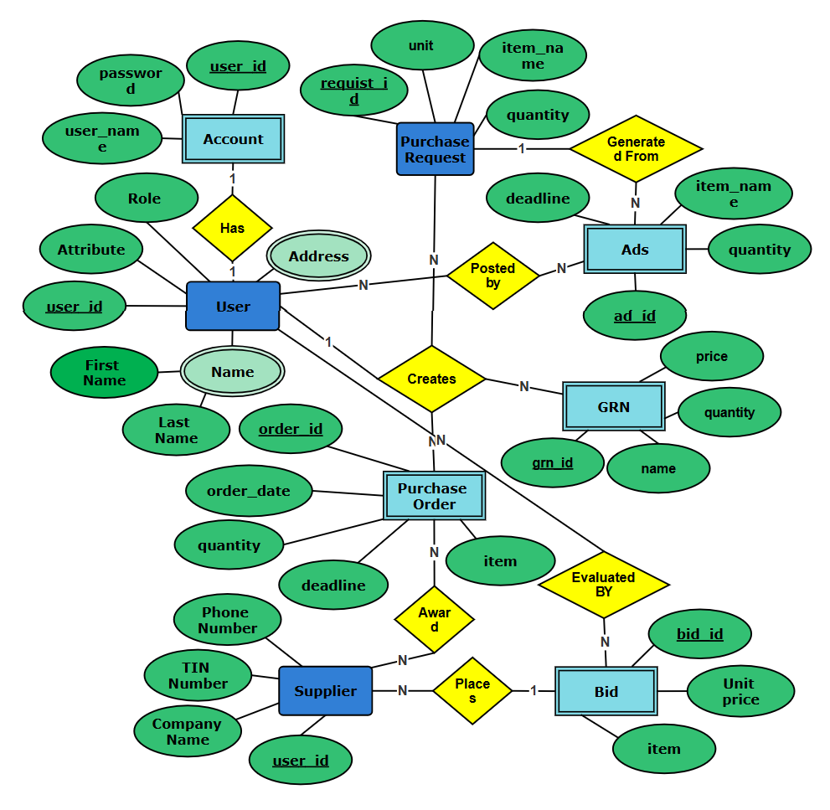
Diagram 3.4 ER Diagram of the System

OO-Relational mapping
Object-Relational Mapping (ORM) bridges the gap between relational databases and object-oriented programming by mapping database tables to classes (objects). Below is the mapping of the system’s relational tables to their corresponding classes:
1. Users Table → User Class
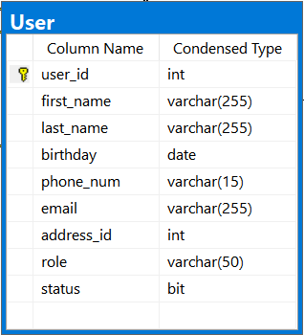
Table Structure: Class Mapping:
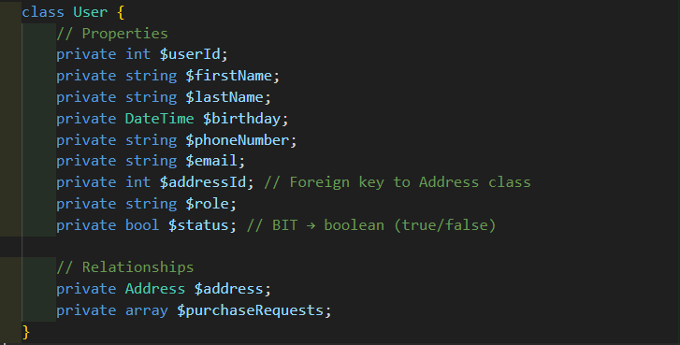

2. Suppliers Table → Supplier Class
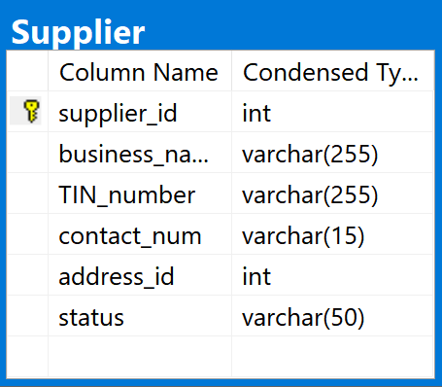
Table Structure: Class Mapping:
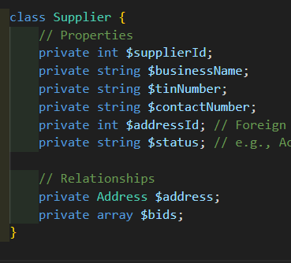
3. PurchaseRequests Table → PurchaseRequest Class
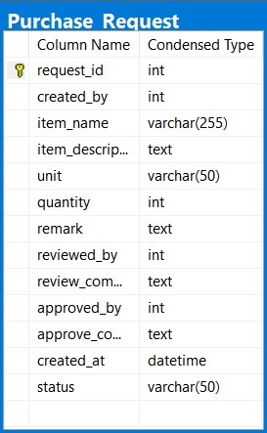
Table Structure: Class Mapping:
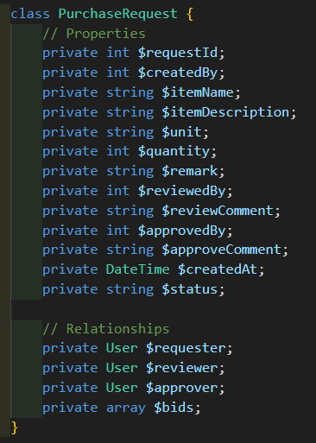

4. Bids Table → Bid Class
Table Structure: Class Mapping:

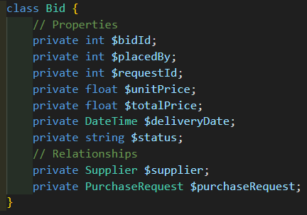

Access Control and Security
Access control and security measures are fundamental to safeguarding the Web-Based Purchase Order Management System, ensuring that only authorized users can access sensitive resources and data. The system employs robust strategies to maintain data privacy and security:
- User Authentication: Secure authentication protocols, including multi-factor authentication (MFA), are implemented to verify user identities. This ensures that only authorized individuals can access the system, significantly reducing the risk of unauthorized access.
- Authorization: Role-Based Access Control (RBAC) is employed to enforce permissions based on user roles. Each role is granted specific access to system resources, ensuring that users can only perform actions aligned with their responsibilities.
- Data Encryption: All sensitive data, including user credentials and procurement records, is encrypted both in transit and at rest. This is achieved using industry-standard encryption algorithms such as AES-256 and TLS protocols, ensuring data confidentiality and protection against breaches.
- Secure Session Management: Active sessions are securely managed, with automatic timeouts and token invalidation for inactive users. This prevents unauthorized use of an open session and mitigates risks associated with session hijacking.
- Intrusion Detection and Prevention: The system incorporates intrusion detection mechanisms to monitor and identify potential security threats. Real-time alerts and automated responses ensure timely mitigation of risks.
- Data Integrity Measures: Checksums and hashing techniques are used to verify the integrity of stored data, ensuring that procurement records and transactions remain unaltered and reliable.

Global Software Control
Global software control in the Web-Based Purchase Order Management System ensures that the overall flow of information and processes within the system is consistent, synchronized, and efficient. This involves a well-coordinated architecture that facilitates communication and control among the various subsystems and modules of the platform. Below, the mechanisms that underpin global software control are outlined in detail:
- Centralized Orchestration
The system employs a centralized controller layer within the backend architecture, which acts as the main orchestrator for all workflows. This controller layer ensures that each subsystem functions cohesively, preventing conflicts and redundancies. It coordinates requests, manages inter-module communication, and oversees system-wide state transitions.
Key responsibilities of the centralized controller include:
- Routing Requests: Handling user-initiated actions such as purchase requests, bid submissions, and approvals, and directing them to the appropriate subsystem for processing.
- Error Handling: Capturing and managing errors at both the subsystem and global levels to maintain system stability.
- State Management: Maintaining a consistent state across all workflows, ensuring that updates in one subsystem are immediately reflected in related areas.
- Request Lifecycle Management
Each request initiated within the system follows a structured lifecycle that ensures proper handling from initiation to completion:
- Request Initiation: Requests are initiated by users through the frontend interface, where a Logistics Unit employee might create a purchase request or a supplier might place a bid. Input data is validated at the user interface level to ensure completeness and correctness before submission.
- Backend Processing: Once validated, requests are forwarded to the backend controller, which assigns them to the relevant subsystem based on predefined workflows; for example, a purchase request is routed to the approval subsystem, while a bid submission is forwarded to the procurement subsystem.
- Subsystem Synchronization: Subsystems interact through standardized Application Programming Interfaces (APIs) to exchange data and maintain a synchronized state. For example, the procurement workflow subsystem communicates with the supplier management subsystem to validate supplier data, and the reporting subsystem retrieves updates from the database to reflect the latest procurement activities.
- Notification and Feedback: Upon processing, the system provides real-time feedback to users. Notifications are sent to relevant stakeholders, such as a manager receiving an alert for pending approvals or a supplier being informed of an awarded bid.
- Communication Between Subsystems
Inter-subsystem communication is governed by a set of clearly defined protocols and standards:
- Message Queues: The system uses message queues to manage asynchronous communication between subsystems, ensuring efficient handling of high volumes of transactions.
- Event-Driven Architecture: Subsystems are designed to react to specific events (e.g., a purchase request approval triggering the posting of a supplier bid ad).
- Data Consistency Protocols: The system implements transaction management to maintain data consistency during multi-step processes, such as bid evaluations and purchase order generations.
- Security and Control Mechanisms
To ensure secure and controlled operations, the system incorporates Role-Based Access Control (RBAC), where user roles determine access privileges, preventing unauthorized interactions with critical subsystems. Additionally, active user sessions are centrally managed to prevent duplicate or conflicting actions, ensuring smooth and secure operation across the system.
- Synchronization and Scalability
To ensure seamless operation and scalability, the system employs scalable backend services, allowing each subsystem to be scaled independently to accommodate increasing workloads. Frequently accessed data is cached to reduce database load and improve response times, while load balancing distributes traffic across multiple servers to ensure optimal performance during peak usage periods.

Boundary Conditions
Boundary conditions defines the limits or extreme values of input variables or data structures that a software system is designed to handle. These conditions are crucial to consider during the software development phase because they can reveal potential vulnerabilities or unexpected behavior in the system.
- Initial Conditions
- User Login: Employees, suppliers, or administrators initiate interactions by logging into the system using valid credentials.
- System Initialization: The system verifies the user’s role and permissions by querying the database and loads personalized dashboards tailored to the user's needs.
- Normal Operation
- Procurement Workflow: Employees submit purchase requests, which undergo approval by designated administrators. Notifications keep users updated about the progress at each stage.
- Order Management: Suppliers confirm orders, update delivery statuses, and interact with procurement officers through the platform.
- Data Processing: The system continuously auto-saves user activities, such as drafts of purchase requests and partially filled bid submissions, to prevent data loss.
- End Conditions
- Request Completion: Purchase requests are marked as completed when fulfilled or rejected, with records archived for future reference.
- Session Termination: Users log out, and the system securely terminates their session by invalidating tokens and releasing resources.
- Order Fulfillment Closure: Once a purchase order is delivered and verified, the system marks it as closed and generates performance reports.
- Exceptional Conditions
- Network Failures: The system detects connectivity issues and automatically retries operations, such as saving draft requests or submitting bids, at regular intervals. To keep users informed, the system also notifies them of intermittent network problems and provides prompts to check their internet connection for resolution.
- Unauthorized Access: Invalid login attempts trigger alerts, and the system temporarily locks accounts after multiple failed attempts to enhance security. Administrators are immediately notified of such suspicious activities, allowing them to take necessary actions promptly. Additionally, audit logs meticulously capture the details of these events, including the time, user information, and the nature of the activity, providing a robust mechanism for tracking and reviewing security incidents.
- Concurrent Modifications: When multiple users attempt to modify the same data, such as a supplier's profile, the system temporarily locks the record to prevent conflicts and maintain data integrity. During this time, users are notified of the ongoing edits and provided with options to either refresh the data to view the latest changes or save their inputs later. This mechanism ensures collaborative workflows without overwriting or losing critical information.
- Timeout Scenarios: If users are inactive for a prolonged period, the system automatically saves their progress and logs them out to enhance security and protect data. Notifications are sent when sessions are nearing expiration, allowing users the opportunity to extend their sessions if needed, ensuring a seamless user experience without interruptions.
- Extreme Conditions
- High Traffic or Load: Auto-scaling mechanisms allocate additional resources to maintain performance under heavy traffic, such as during procurement deadlines or supplier bid submissions. To further enhance efficiency, the system employs caching for frequently accessed data, such as approved supplier lists, significantly reducing database query loads and ensuring a smooth user experience even during peak usage periods.
- System Downtime: In the rare case of system maintenance or unexpected downtime, users are redirected to a maintenance page displaying the estimated restoration time.
- Payment Gateway Failures: If external payment gateways are unavailable, payment requests are queued and retried once services are restored. Users are notified about delays.

Conclusion
In conclusion, the development of the Web-Based Purchase Order Management System marks a significant step toward modernizing and streamlining procurement operations at Upper Awash Agro Industry. The system effectively addresses the inefficiencies of the manual, paper-based process by introducing automation, role-based access control, and real-time tracking. By reducing approval times, eliminating paperwork, and improving supplier engagement, the platform enhances overall procurement efficiency. Additionally, the system’s data-driven approach ensures transparency and accountability through audit trails and reporting capabilities, enabling management to make informed decisions. Its integration with suppliers facilitates seamless communication and competitive bidding, ultimately leading to cost savings and better vendor relationships. The scalable and modular design also ensures adaptability to future organizational growth and evolving procurement needs.
Beyond operational improvements, the system contributes to environmental sustainability by significantly reducing paper usage and minimizing redundant administrative tasks. With these advancements, Upper Awash Agro Industry is well-positioned to enhance its procurement efficiency, maintain regulatory compliance, and achieve long-term cost-effectiveness, making this system a vital asset for the company's future growth and innovation.

References
- DashPO, "Purchase Order Management System: A Complete Guide," DashPO, 2025. https://dashpo.net/blog/purchase-order-management-system/
- Knack, "Guide to Web-Based Purchase Order Systems," Knack, 2024. https://www.knack.com/blog/web-based-purchase-order-system-guide/
- K. B. Karlos, "Database Project: E-commerce Order Management System with SQL," Medium, 2023. https://medium.com/@karlos-b/database-project-e-commerce-order-management-system-with-sql-d986b044d92
- E. Karttunen, K. Lintukangas, and J. Hallikas, "Digital transformation of the purchasing and supply management process," International Journal of Physical Distribution & Logistics Management, vol. 53, no. 5/6, pp. 685–706, 2023. doi: 10.1108/IJPDLM-06-2022-0199
- Oboloo, "The Complete Guide to Online Procurement Systems," Oboloo, 2024. https://oboloo.com/the-complete-guide-to-online-procurement-systems/
- IEEE, "WebTP: A Benchmark for Web-Based Order Management Systems," IEEE Conference Publication, 2024. https://ieeexplore.ieee.org/document/772955
- Polyinfomsbte, "Sample Test Cases for Purchase Order Management System," Blogspot, 2022. https://polyinfomsbte.blogspot.com/2022/11/write-sample-test-cases-for-purchase.html
- IEEE, "Building a SOA-Based Model for Purchase Order Management in E-Commerce Systems," IEEE Conference Publication, 2024. https://ieeexplore.ieee.org/document/6545945
- goFTx, "A Complete Guide to Purchase Order Management Systems," goFTx, 2024. https://goftx.com/blog/purchase-order-management/
- Scribd, "Identify System Specification & Design Test Cases For Purchase Order," Scribd, 2024. https://www.scribd.com/document/533927477/Book1
- R. S. Pressman, Software Engineering: A Practitioner’s Approach, 7th ed. McGraw-Hill, 2009.
- B. Bruegge and A. H. Dutoit, Object-Oriented Software Engineering Using UML, Patterns, and Java. Pearson, 2009.
- I. Sommerville, Engineering Software Products: An Introduction to Modern Software Engineering. Pearson, 2019.
- A. Dennis, B. H. Wixom, and D. Tegarden, Systems Analysis and Design: An Object-Oriented Approach with UML. Wiley, 2016.
- IBM, "Rational Software Architect 9.7.0," IBM Documentation, 2023. https://www.ibm.com/docs/en/rational-soft-arch/9.7.0

Appendix

Interview Questions

For Suppliers
General Experience:
- How do you currently submit bids or proforma invoices to Upper Awash Agro Industry?
- What challenges do you face in communicating with the procurement team (e.g., delays, unclear requirements)?
- How do you track the status of your bids or purchase orders today?
Registration & Profile Management:
- What business information (e.g., certifications, product catalogs) would you need to provide during registration?
- Would you prefer a self-service portal to update your profile, or should changes require admin approval?
Bidding Process:
- How much time do you typically spend preparing a bid? What information is most critical for you to include?
- How should the system notify you about new procurement opportunities (e.g., email alerts, dashboard updates)?
- Would you like to see historical bid data (e.g., past winning bids) to inform future submissions?
Integration & Accessibility:
- Are you comfortable using a web-based system, or would you need training/support?
- Do you need mobile access to the platform for urgent updates or notifications?

Feedback & Improvements:
- What features would make bidding more efficient (e.g., bulk bid submissions, automated price comparisons)?
- How can the system improve transparency in bid evaluation and award decisions?

For Administrators
User Management:
- What roles and permissions are required (e.g., admin, procurement officer, general manager)?
- How should the system handle approvals for new supplier registrations?
- What criteria would trigger a supplier ban, and how should the system enforce it?
Security & Compliance:
- What data protection measures are critical (e.g., encryption, audit trails)?
- Existence about Company ICT policies or procurement regulations?
System Configuration:
- What approval workflows are needed (e.g., multi-level approvals for high-value purchases)?
- How should the system prioritize purchase requests (e.g., urgency, budget limits)?
Reporting & Monitoring:
- What reports are essential for auditing (e.g., supplier performance, procurement delays)?
- How frequently should automated reports be generated, and who should receive them?
Technical Requirements:
- Are there existing IT systems (e.g., inventory management) that are in use?
- What backup and recovery protocols do they imploy?

For Employees
  - Logistics & Supply Unit
- How do you currently identify inventory shortages and initiate purchase requests?
- What information is missing from the current purchase request forms?
- How should the system notify you about approval statuses or delivery updates?
  - Procurement Unit
- What criteria do you use to evaluate bids (e.g., price, delivery time, supplier reputation)?
- How should the system streamline bid comparisons (e.g., side-by-side views, scoring tools)?
- What challenges do you face in generating purchase orders or Goods Received Notes (GRNs)?
  - Budget Control Unit
- How do you verify if purchase requests align with departmental budgets?
- Should the system automatically flag requests that exceed budget limits?
  - General Managers
- What factors influence your approval/denial of purchase requests (e.g., cost, urgency)?
- How should the system escalate urgent requests for faster approvals?
  - General Feedback
- What manual tasks in the current process are most time-consuming?
- How can the system reduce errors in data entry or communication?

Cross-Functional Questions
Training & Adoption:
- What training/support is needed to ensure smooth adoption of the new system?
- How can the system’s interface be designed to minimize the learning curve?
Risk Mitigation:
- What are the biggest risks in transitioning to a digital system (e.g., resistance to change, technical failures)?
- How should the system handle internet outages in remote locations?

Images
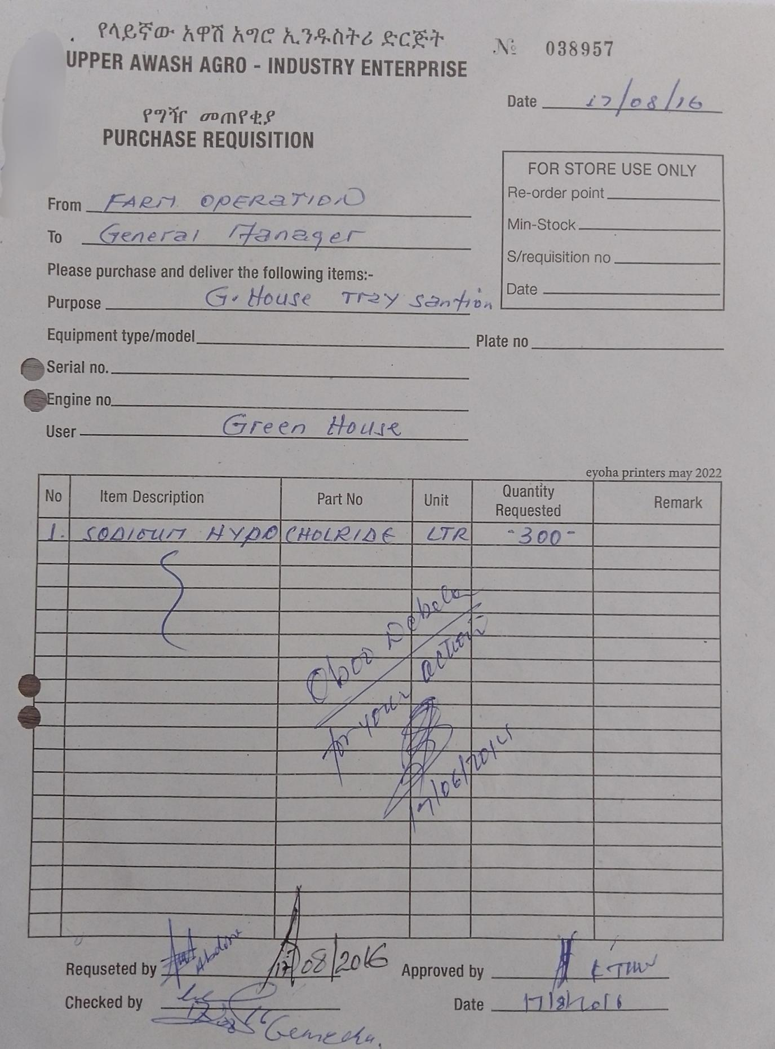
Image 0.1 Purchase Requisition Fom
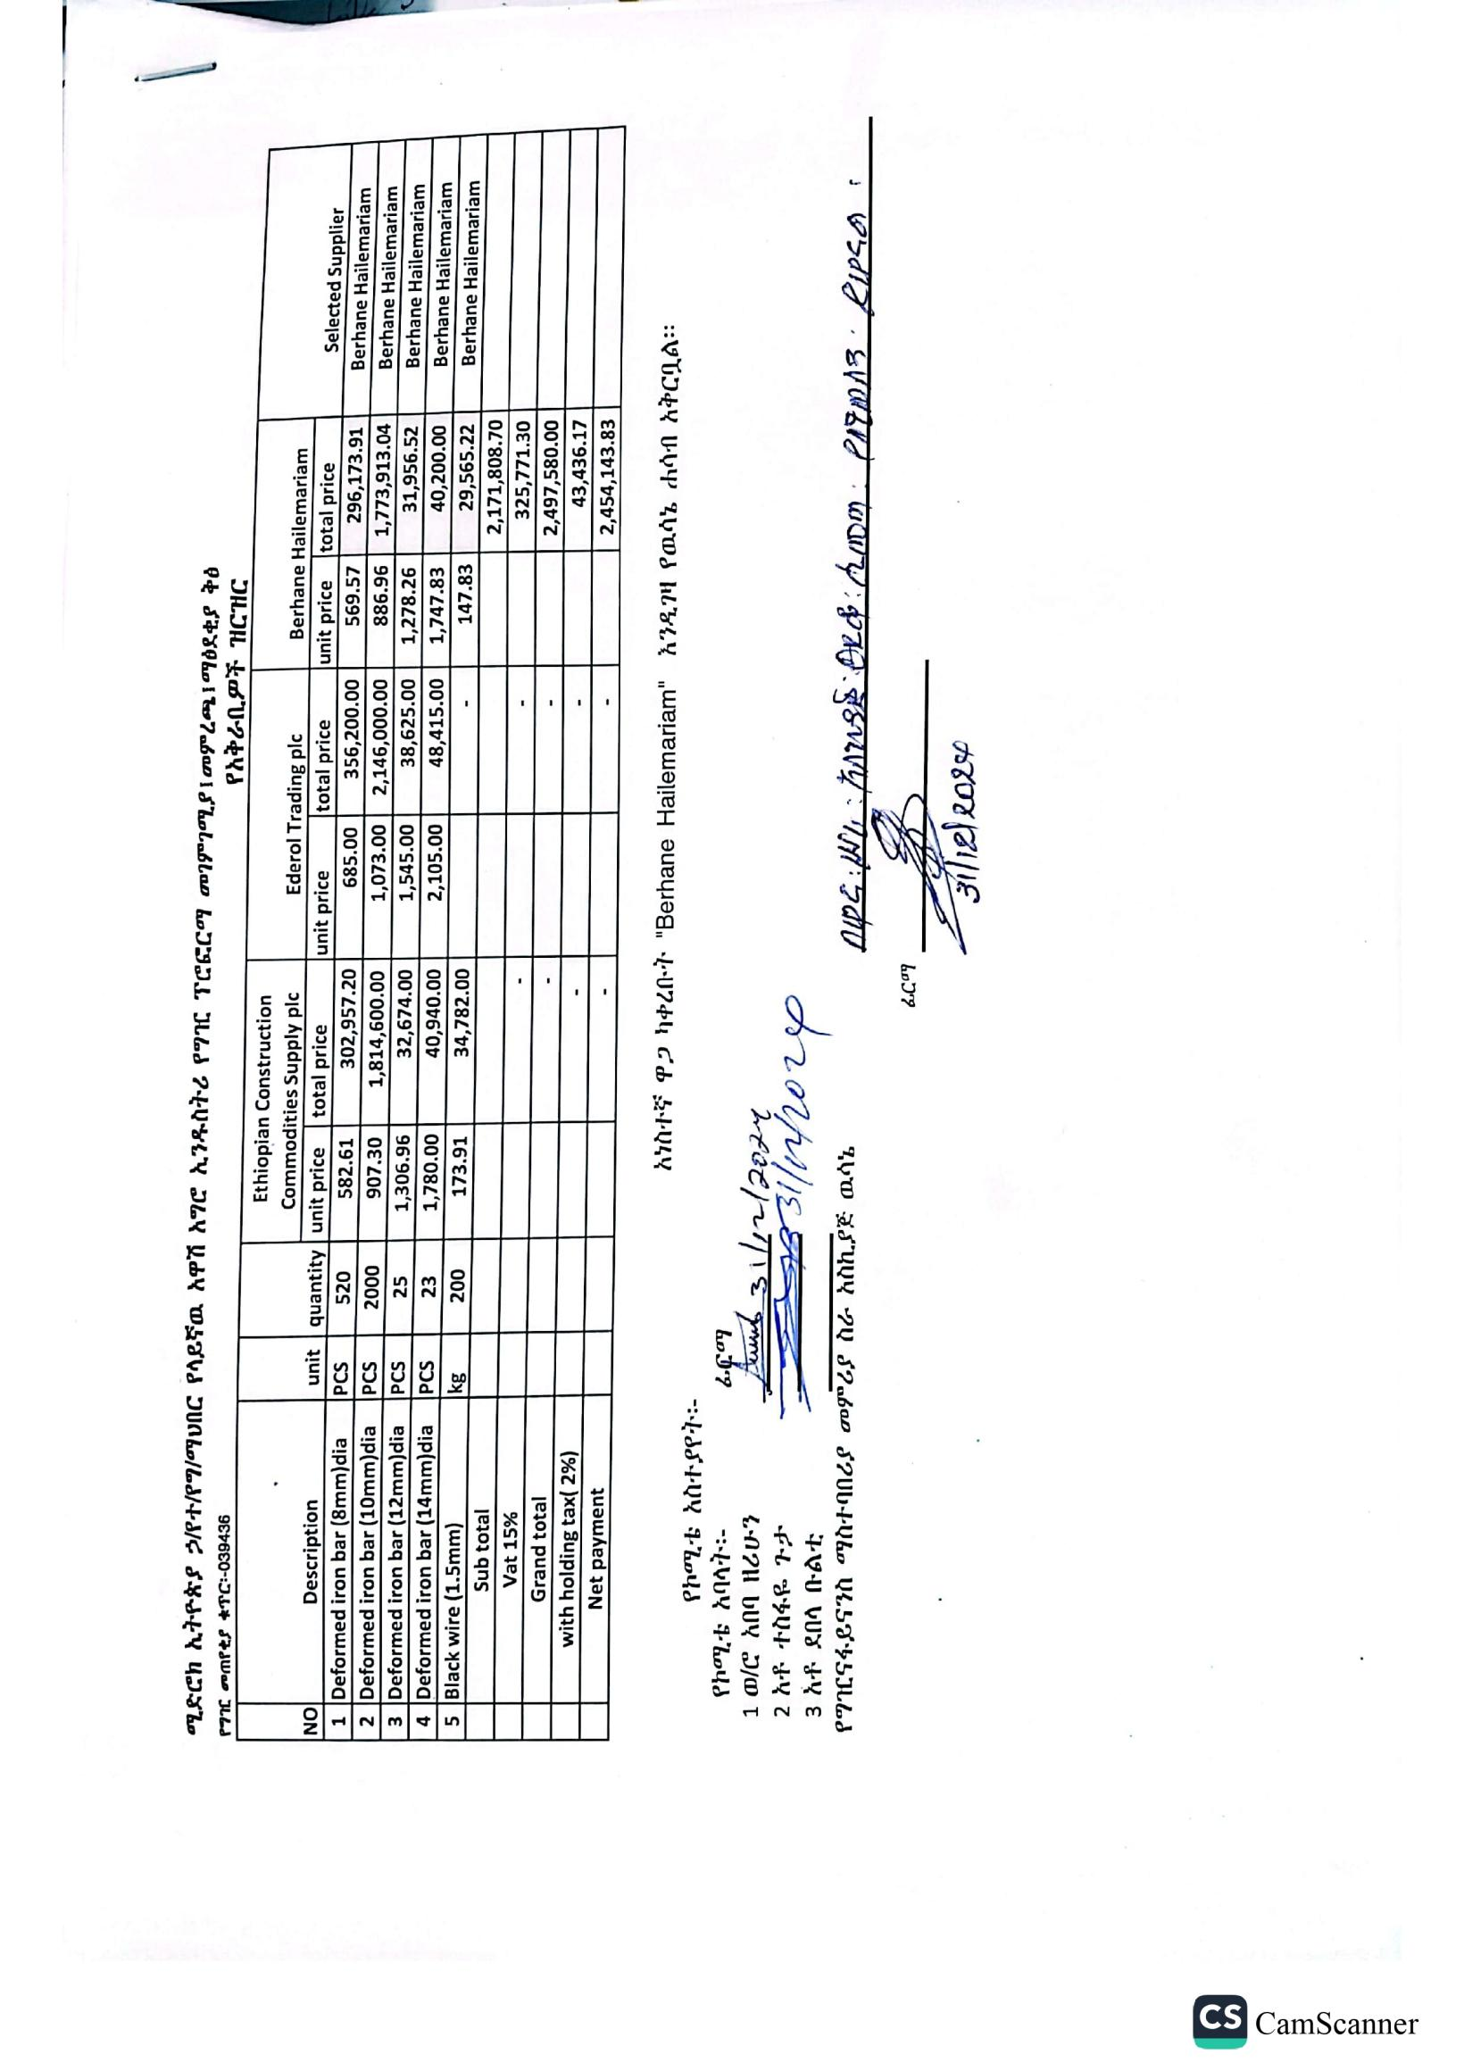
Image 0.2 Proforma Evaluation Form
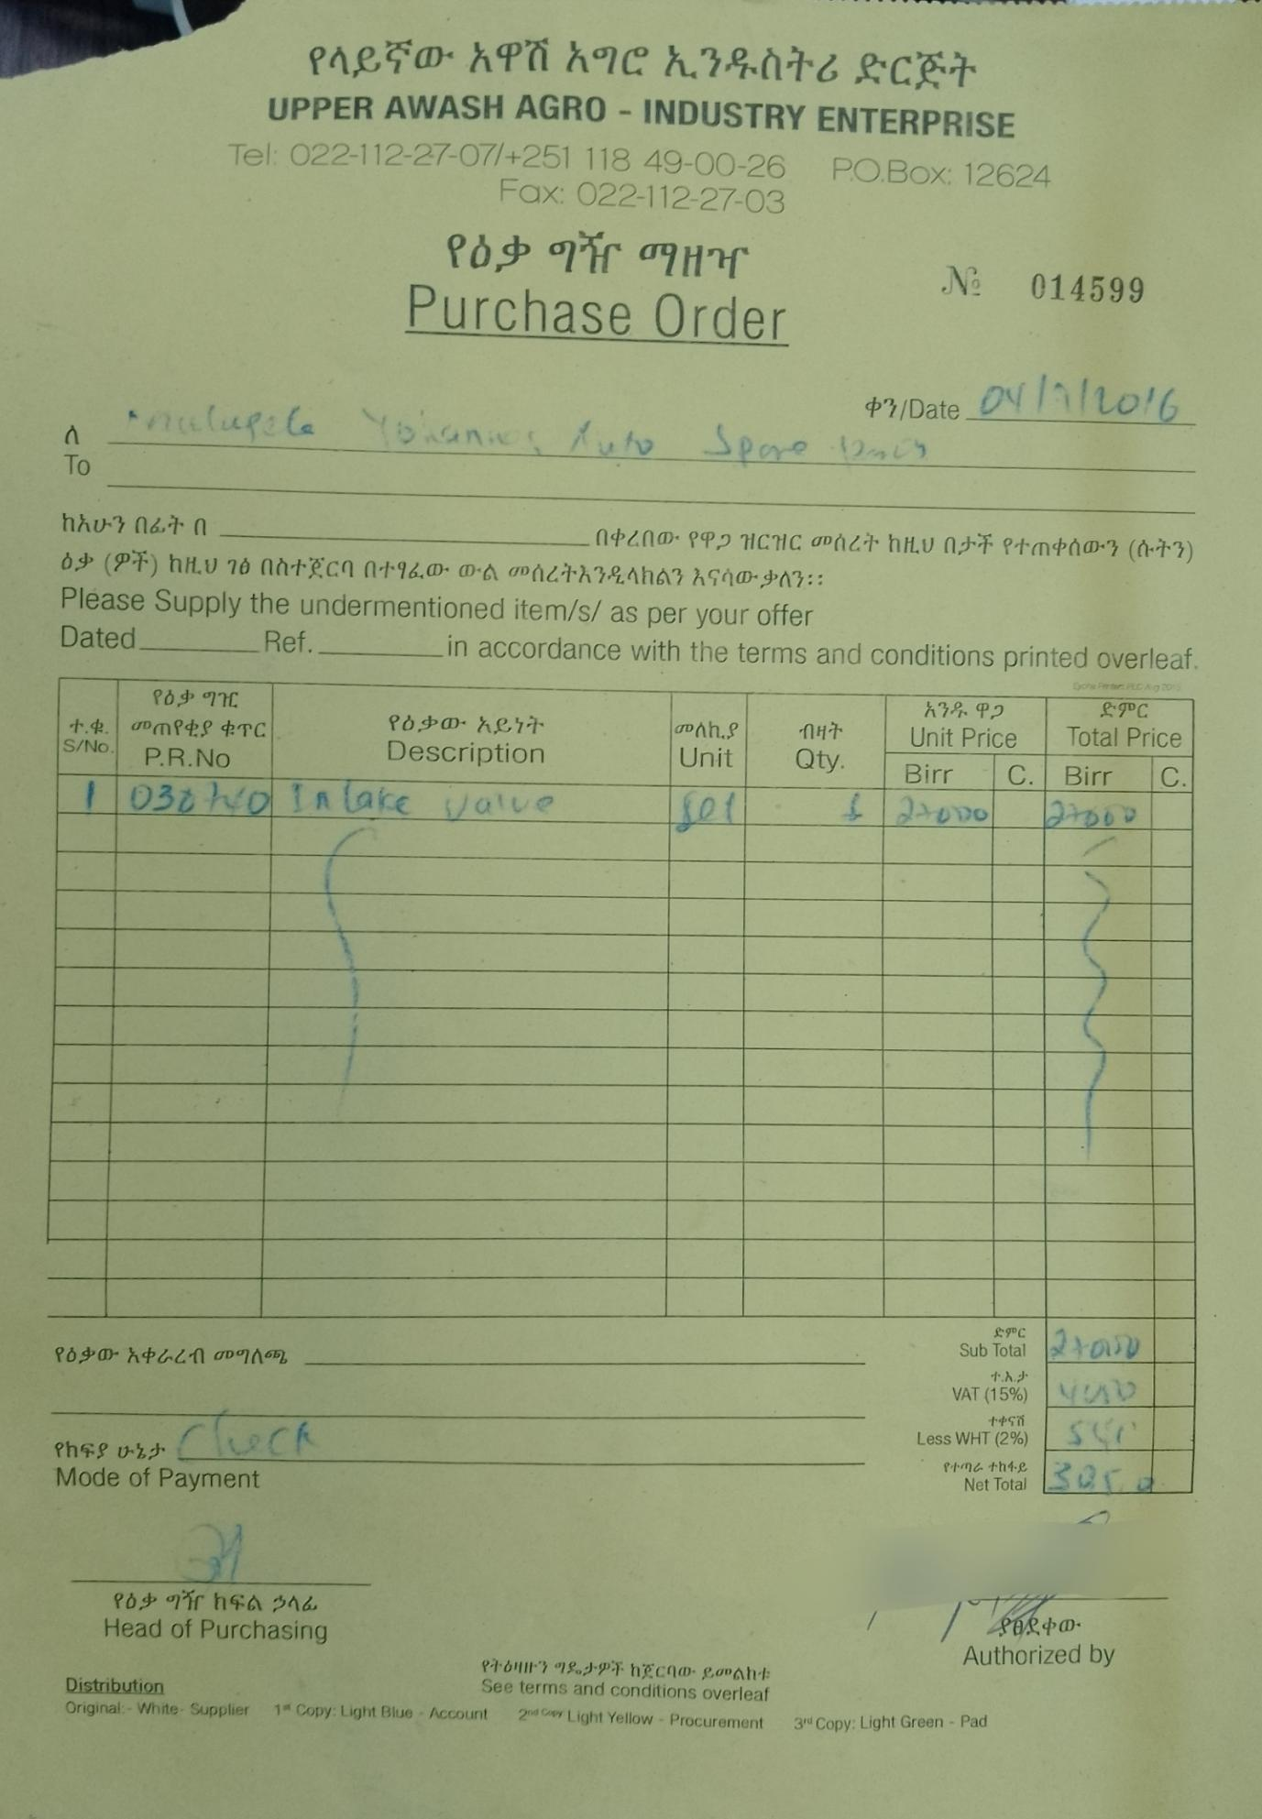
Image 0.3 Purchase Order Form

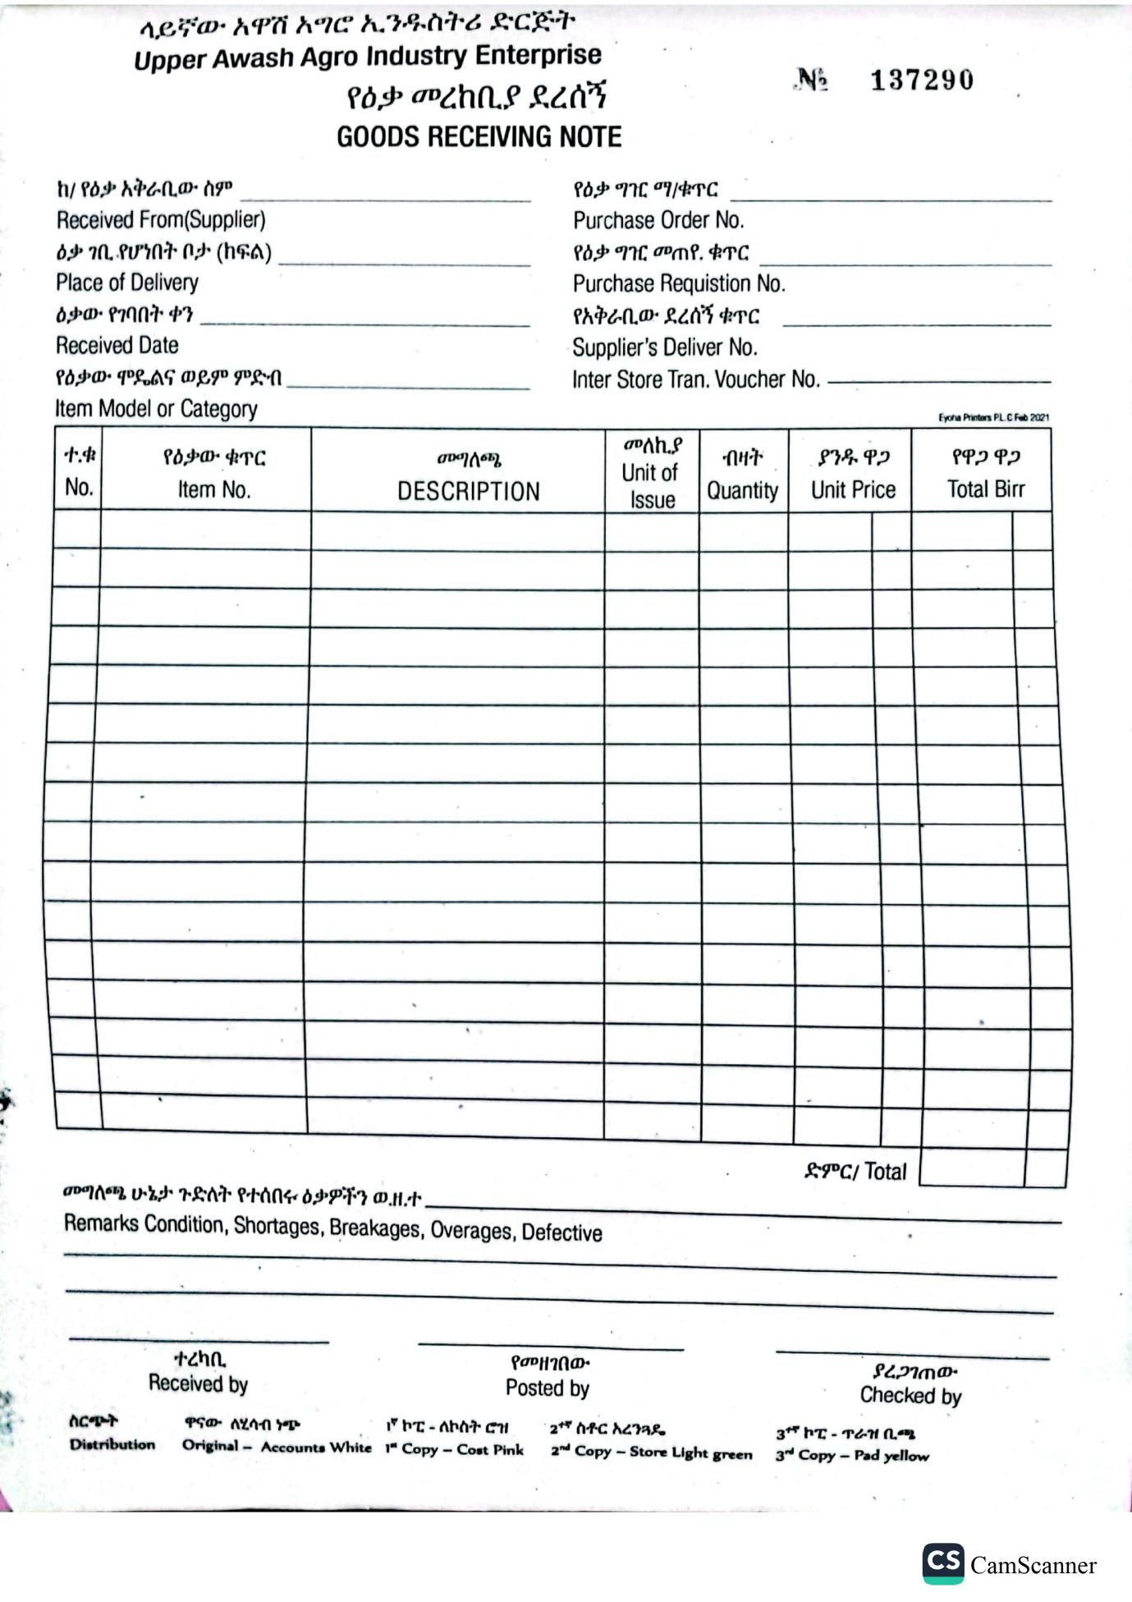
Image 0.4 GRN Form
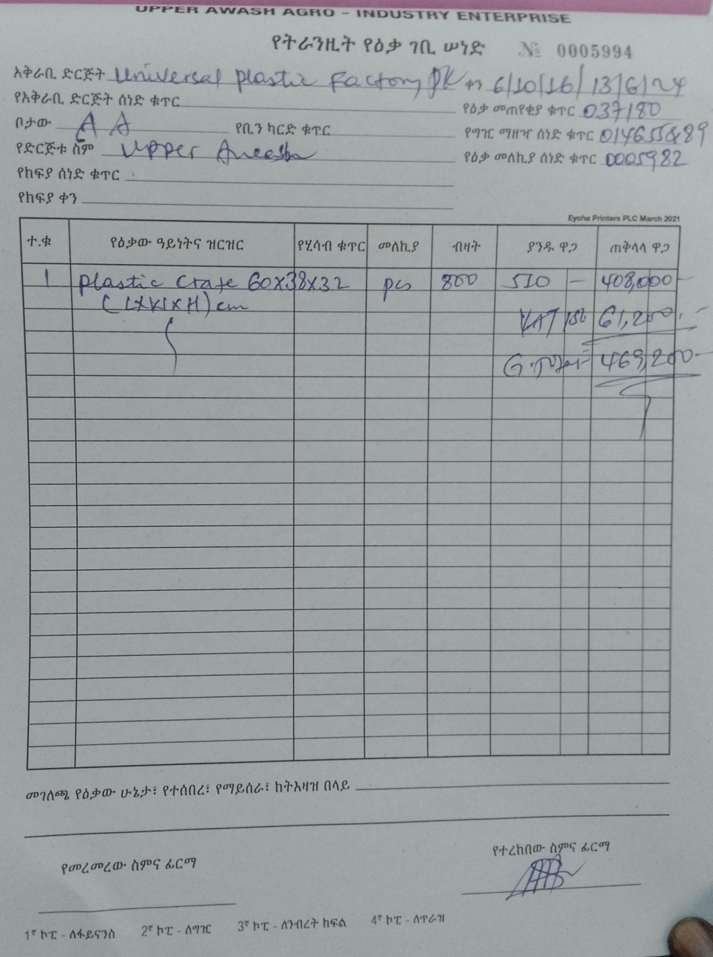
Image 0.5 Goods in Transit Form

